

MODEL
SF 1900LS
MICRO PROCESSOR
CONTROLLED CONVEYOR OVEN
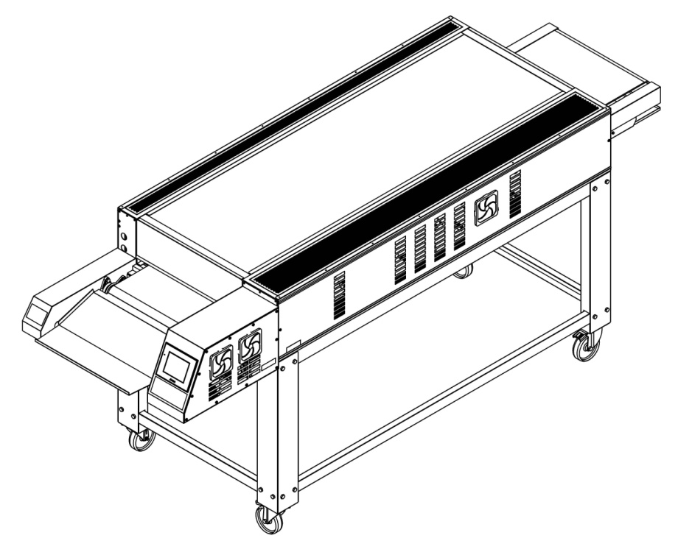

USER & MAINTENANCE MANUAL

ŞENGÜN MAKİNA İNŞAAT ve KIRTASİYE SAN. TİC. LTD. ŞTİ

These instructions apply only if the country code is shown on the device. If the country code does not appear on the device, refer to the technical instructions that give instructions for adapting the device to the country.

This device must be installed in accordance with regulations. Refer to the instructions before installing and using the device.


WARRANTY CERTIFICATE
SERIAL NUMBER :
SALE DATE :
Sold at the above date SF – 1900LS MODEL MICROPROCESSOR CONTROL BLOWING OVEN is guaranteed against production failures for 1 Year by ŞENGÜN MAKİNA İNŞAAT ve KIRTASİYE SAN. TİC. LTD. ŞTİ.

Warranty Terms;
- Warranty terms start after the product delivery for 1 year.
- Recommended daily working time is 10 hours. The scope of warranty is assessed by year or by working hours.
- Documents are invalid, if haven’t sale date and confirm signature of company. You have to show the warranty certificate to benefit from the warranty.
- Device is guaranteed against defects if mount and use as described ın the use and maintenance manual.
- Detection the location of defects, and elimination of the problems are responsibilities of the ŞENGUN MAKİNA…
- Warranty terms include only one device. You can’t claim any rights or compensation for another devices.
- If Changes are made at the type, model and serial numbers, the warranty eliminates.
- If material, worker or assembly defects appear, repaired free by ŞENGÜN MAKİNA at the product warranty period (Transportation cost is not included).
- Failures are only repaired by ŞENGÜN MAKİNA’s personal. The intervention of unauthorized person, cancel the appliance of warranty.
- Installation have to be done by ŞENGÜN MAKİNA’s personal. İf usage place changes, customer must give information to ŞENGÜN MAKİNA
- In the event of failure service must be informed.
- The failures and damages given by external factors are out of the warranty terms.
- Any failure of the product warranty period is added to the product warranty time. The repair time is until 20 working days.
- Istanbul courts are competent in case of dispute.
AUTHORIZED PERSON
STAMP –SIGNATURE

PRESENTATION

Dear Users,
Thank you for your prefer our machine and confidence in our company. Our machines are used in 39 countries.
Our machine is manufactured according to international standards. Please read the operating manual to get the mast out of your machine .Please note the following warnings before calling our service.

ŞENGÜN MAKİNA

- Please read the manual carefully before installing the machine.
- The machine will be out of warranty when your operate the machine with at read.
- Please read carefully the manual that gives you information on the installation is prepared in accordance with the legal regulations before arriving at the machine installation.
- For information you coo not understand , ask your nearest out horized service
- Please note that if the technical service personnel is kept waiting you will be billed for each hour.

IMPORTANT WARNINGS AND SAFETY INFORMATIONS
 WARNING: This manual contains important safety and installation-operation instructions. Require all operators to read this manual thoroughly before installing, operating or servicing this equipment. Improper installation, adjustment, alteration, service or maintenance can cause property damage, injury or death.
WARNING: This appliance is not intended for use by young children or infirm persons unless they have been adequately supervised by a responsible person to ensure that they can use the appliance safely. Young children should be supervised to ensure that they do not play with the appliance.
WARNING: Improper installation, adjustment, alteration, service or maintenance can cause property damage, injury or death. Read the installation, operating and maintenance instructions thoroughly before installing or servicing this equipment.
WARNING! Do not work around conveyor belt with long hair, loose clothing, or dangling jewelry. Getting caught in the belt could result in serious injury.
WARNING! For your safety, do not store or use gasoline or other flammable vapors or liquids in the vicinity of this or any other appliance.
 WARNING! If the power supply cord damaged, do not attempt to operate the unit. Contact a service agent or qualified electrician to repair!
WARNING! Do not use paper when placing food product through the oven! Usage of flammable materials may cause a fire and should never be placed in the oven.
WARNING! Do not put any object to anywhere of the oven except the conveyor.
WARNING! Always be careful while you are working.

- The oven must be placed under a ventilator to provide for adequate air supply.

- Minimum clearances must be provided from all walls and combustible materials. Look “spacing requirements” section for more information.

- Always keep the oven clean and clear combustible materials.

- Keep adequate clearance for air openings.

- Do not obstruct the ventilation holes.

- The oven is to be operated only on as shown on the specification plate.

- This manual should be retained for future reference.

- Prepare a list of what you should do when you smell gas and keep it near the oven.
- Gas does not pass through the burner without electricity.

Responsibilities of the Purchaser Company
Responsibilities of the purchaser company are written at bottom;
- To see that the electric and gas services for the oven are installed in accordance with the manufacturers specification.
- İnstalling the oven and placing it as suggested at the catalogue.
- To see that the electric services are connected properly by a qualified installer of your choice.

WARNING

Cleaning and maintenance are the most important factors of oven performance. The processes which are not available in the manual can cancel the appliance of warranty, cause property damage, injury or death. Read and understand the instructions in the manual

WARNING

Cleaning and maintenance are the most important factors of oven performance. The processes which are not available in the manual can cancel the appliance of warranty, cause property damage, injury or death. Read and understand the instructions in the manual

TABLE OF CONTENTS

WARRANTY CERTIFICATE

SECTION 1: INTRODUCTION

  - Introduction of Body Elements

  - Functions of Components
1.2.1 Oven Body
1.3 Placing the ovens individually or One On the Top of Each Other
1.4 Control with Micro-processor
1.5 Infra-red Heating Panels
1.6 Heating Zones
1.7 Conveyor (Belt)
1.8 Graphical Features
1.9 Table of the Electric Properties of the Oven
1.10 Dimensioning
SECTION 2: MOUNTING
2.1Front Residuals Collection Sheet Slide (Right and Left)

2.2 Front Waste Collection Sheet

2.3 Front Product Extraction Sheet

2.4 Extraction Panel

2.5 Rear Waste Collection Sheet

2.6 Rear Side Protection Sheet (Right and Left)

2.7 Rear Bearing Protection Sheet (Right and Left)

2.8 Belt Cleaner Sheet

2.9 High Chassis Assembly

2.10 Low Chassis Assembly

2.11 Middle Chassis Assembly

2.12 Chassis-Oven Assembly

2.13 Double Floor Oven Assembly

SECTION 3: INSTRUCTIONS FOR USE

3.1 Ventilation Recommendations

3.1.1 Single Floor Oven

3.1.2 Double Floor Oven

3.2 General Information about Ventilation

3.3 Necessary Elements of the Installation

3.4 Table of the Electrical Technical Properties of the Oven SF 1900LS

3.5 Distance Requirements

SECTION 4: PROGRAMMING, OPERATION AND SHUTOFF

4.1 Utility Programs

4.2 Manual Operation

4.3 Cleaning Program

4.4 Standby Mode

4.5 Warnings

4.6 Shutdown

SECTION 5: TYPES OF FOOD

5.1 Some of Products Cooked in the Oven

5.2 Sample Cooking Programs

5.3 Calculation of Total Output

SECTION 6: CLEANING - MAINTENANCE

6.1 Cleaning of Oven Body

6.2 Cleaning of Cooling Fan Filter

6.3Cleaning of the Components of the Oven

6.3.1 Front and Rear Waste Collection Sheets

6.3.2 Front and Rear Extraction Panel

6.3.3 Front Product Extraction Sheet

6.3.4 Belt Cleaner Sheet

6.3.5 Rear Side Bearing Protection Sheets

6.4Cleaning of the outer surfaces of the Oven

6.5Cleaning of the Mechanical Parts of the Oven

SECTION 7: SPARE PART MANUAL

SECTION 8: ELECTRICAL DIAGRAM

SECTION 9: TROUBLESHOOTING

9.1 Warning of Temperature Limit exceeded

9.2 Displaying of "Low Battery" on the screen

9.3 Conveyor stopped totally or working interruptedly

9.4. Products do not cooked

9.5 Contact with Technical Services

SECTION 10: LABELS

NOTE

SECTION 1: INTRODUCTION

1.1 Introduction of Body Elements:

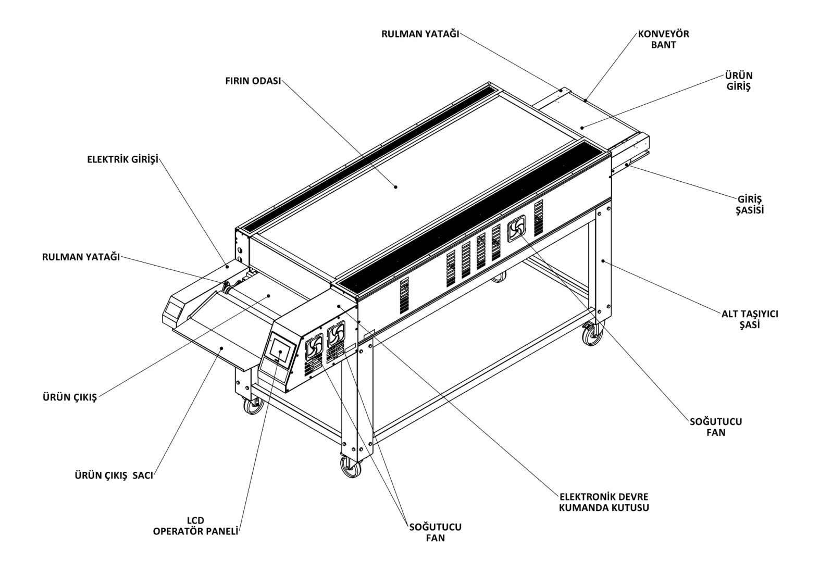
BEARİNG
PRODUCT OUT
PRODUCT OUT PLATE
LCD DISPLAY
COOLING FAN

ELECTRONIC CIRCUIT CONTROL BOX
COOLING FAN
BOTTOM CHASSIS
INTRODUCTION CHASSIS
PRODUCT INTRODUCTION
CONVEYOR BELT
BEARING
ELECTRIC ENTRY
OVEN CHAMBER
1.2 Functions of Components
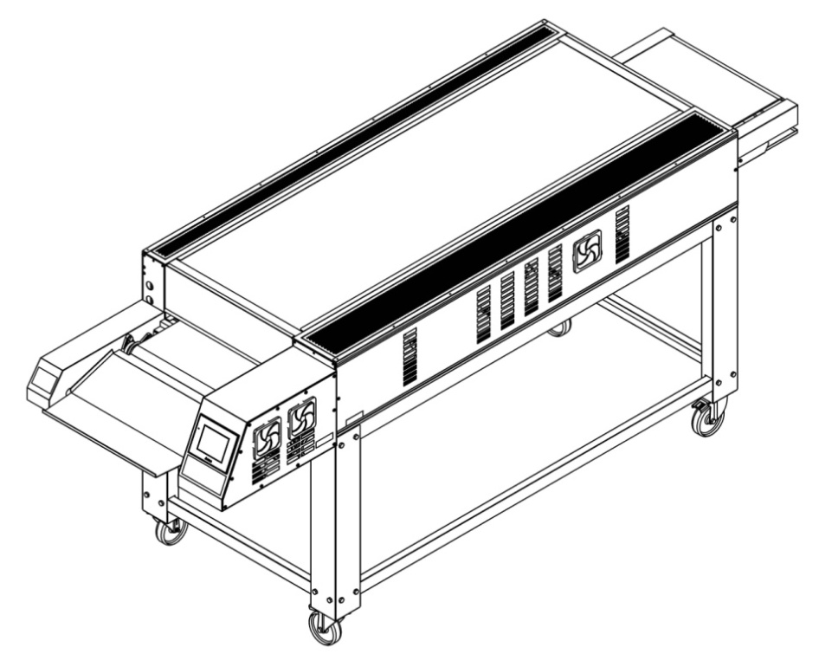
1.2.1 Oven Body
Each SF series oven has a main body.

1.3 Placing the ovens individually or One On the Top of Each Other
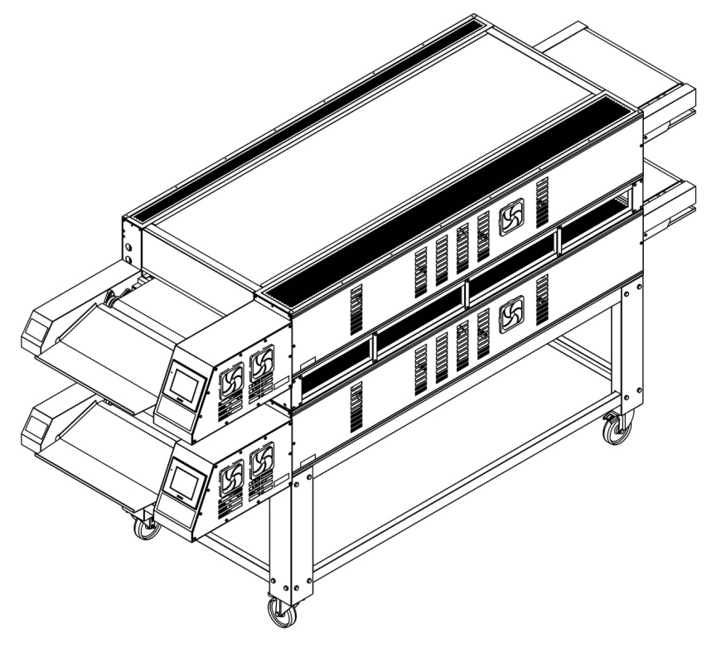
SF series ovens may be used as single or up to two as one on the top of the other. Body of each oven is connected to the chassis. 922 mm counterfort is for Single floor Ovens. 770 mm counterfort is for Double floor Ovens. It may be triple on demand.
1.4 Control with Micro-processor:
Each oven is controlled with an individual programmable micro-processor. Micro-processor controls all functions of the oven. Infrared BOTTOM heating panels can be set between 100 °C and 400 °C. Infrared TOP heating panels can be set between 100 °C and 500 ℃. Cooking time (Conveyor speed) can be set between 10 seconds and 59 minutes for SF 1900LS ovens. Ovens can be programmed to auto cleaning. Energy saving is possible at standby mode. Furthermore, the ovens have service mode helping the service technicians.

1.5 Infra-red Heating Panels:
Heating panels are placed over and under the belt. These panels send infrared heat waves. The waves does not heat the air they pass through. They only heat the TOP side of the product on the belt. So, properly placed products are specially cooked from outside to inside thanks to such special waves.
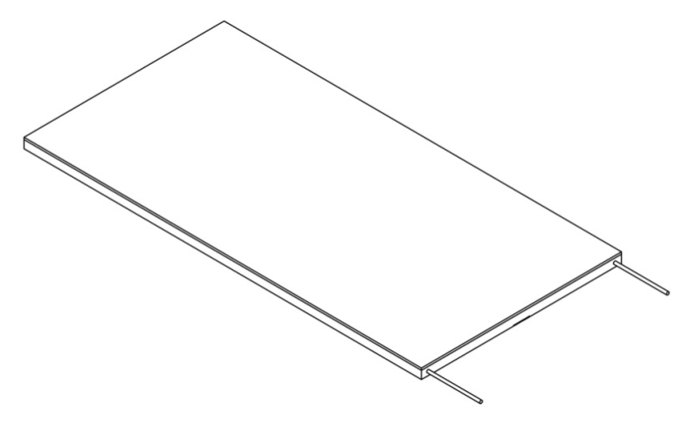

1.6 Heating Zones:
Heating zones have specific places into the oven body. SF 1900LS oven has four different heating zones TOP and BOTTOM temperatures of these zones can be set individually. Four BOTTOM heating zones are available only in this oven.

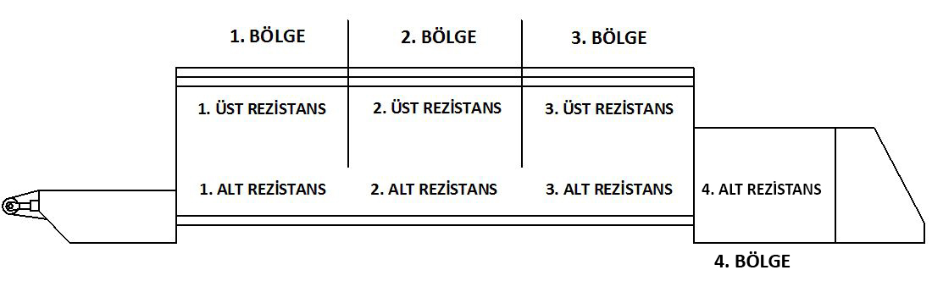
REGION 4
REGION 1
BOTTOM RESISTANCE 4
BOTTOM RESISTANCE 3
BOTTOM RESISTANCE 2
BOTTOM RESISTANCE 1
TOP RESISTANCE 3
TOP RESISTANCE 1
TOP RESISTANCE 2
REGION 3
REGION 2

The temperature difference between the BOTTOM and top heating zones should not exceed 120 °C. Maximum temperature difference between the BOTTOM Zone 1 and Zone 2, Zone 2 and Zone 3, Zone 3 and Zone 4 should not exceed 40 °C.

1.7 Conveyor (Belt):
Conveyor ensures the transition of the product through the inside of the oven. The belt is composed of wire, cord, belt and frame. The belt is controlled with a micro-processor and reach a speed between 10 sec and 59 min in SF 1900LS ovens. The speed of the belt adjust how long the product will remain within the oven and this is cooking time. The width of the belt is 520 mm.

1.8 Graphical Features:
 | SF 1900LS
Conveyor Belt Width : | 520 mm.
Heating Zone (Chamber) Length : | 1925 mm.
Oven Chamber Dimensions : | L 1925 mm. X W 607 x H 125
Conveyor Cooking Area : | 1,01 m²
Rough Dimensions – Single Floor at the bottom : | Oven Width: 984 mm.  Oven Height: 368 mm.  Total Length: 3025 mm.
Rough Dimensions – Double- Floor oven as one on the top of the other : | L 3020 x W 925 x H 1545
Chassis Dimensions for Single Floor oven : | Chassis Height 922 mm.
Chassis Dimensions – Double- Floor oven as one on the top of the other : | Chassis Height 770 mm.
Net Weight : | 390 kg.
Shipment Weight - Single Piece : | 500 kg.
Shipment Dimensions : | L 3150 mm x W 1100 mm x H 600 mm
Average use kW : | 11-13 kW
Allowed Temperature Range : | BOTTOM Infrared: 100 °C – 400 °C  TOP Infrared: 100 °C – 500 ℃
Conveyor Drive System : | Micro-processor controlled conveyor remote control system resistant to mains voltage variable between 208 and 300 watt.
Cooking Time : | 10 sec. – 59 min.
Insulation : | each four side
Heat Source : | 3 TOP heat-releasing  4 BOTTOM heat-releasing
Oven Chamber Steel : | Steel
Outer Body Steel : | 430 Stainless Steel

1.9 Table of the Electric Properties of the Oven:
TABLE OF ELECTRIC PROPERTIES OF OVEN
Voltage | Phase | N | T | Minimum Cable Section | kW | Ampere Loading
 |  |  |  |  |  | L1 | L2 | L3
400V 50/60HZ | 3 | 1 | 1 | 10 mm² | 29,5 | 35,3 | 54 | 37,5

1.10 Dimensioning:
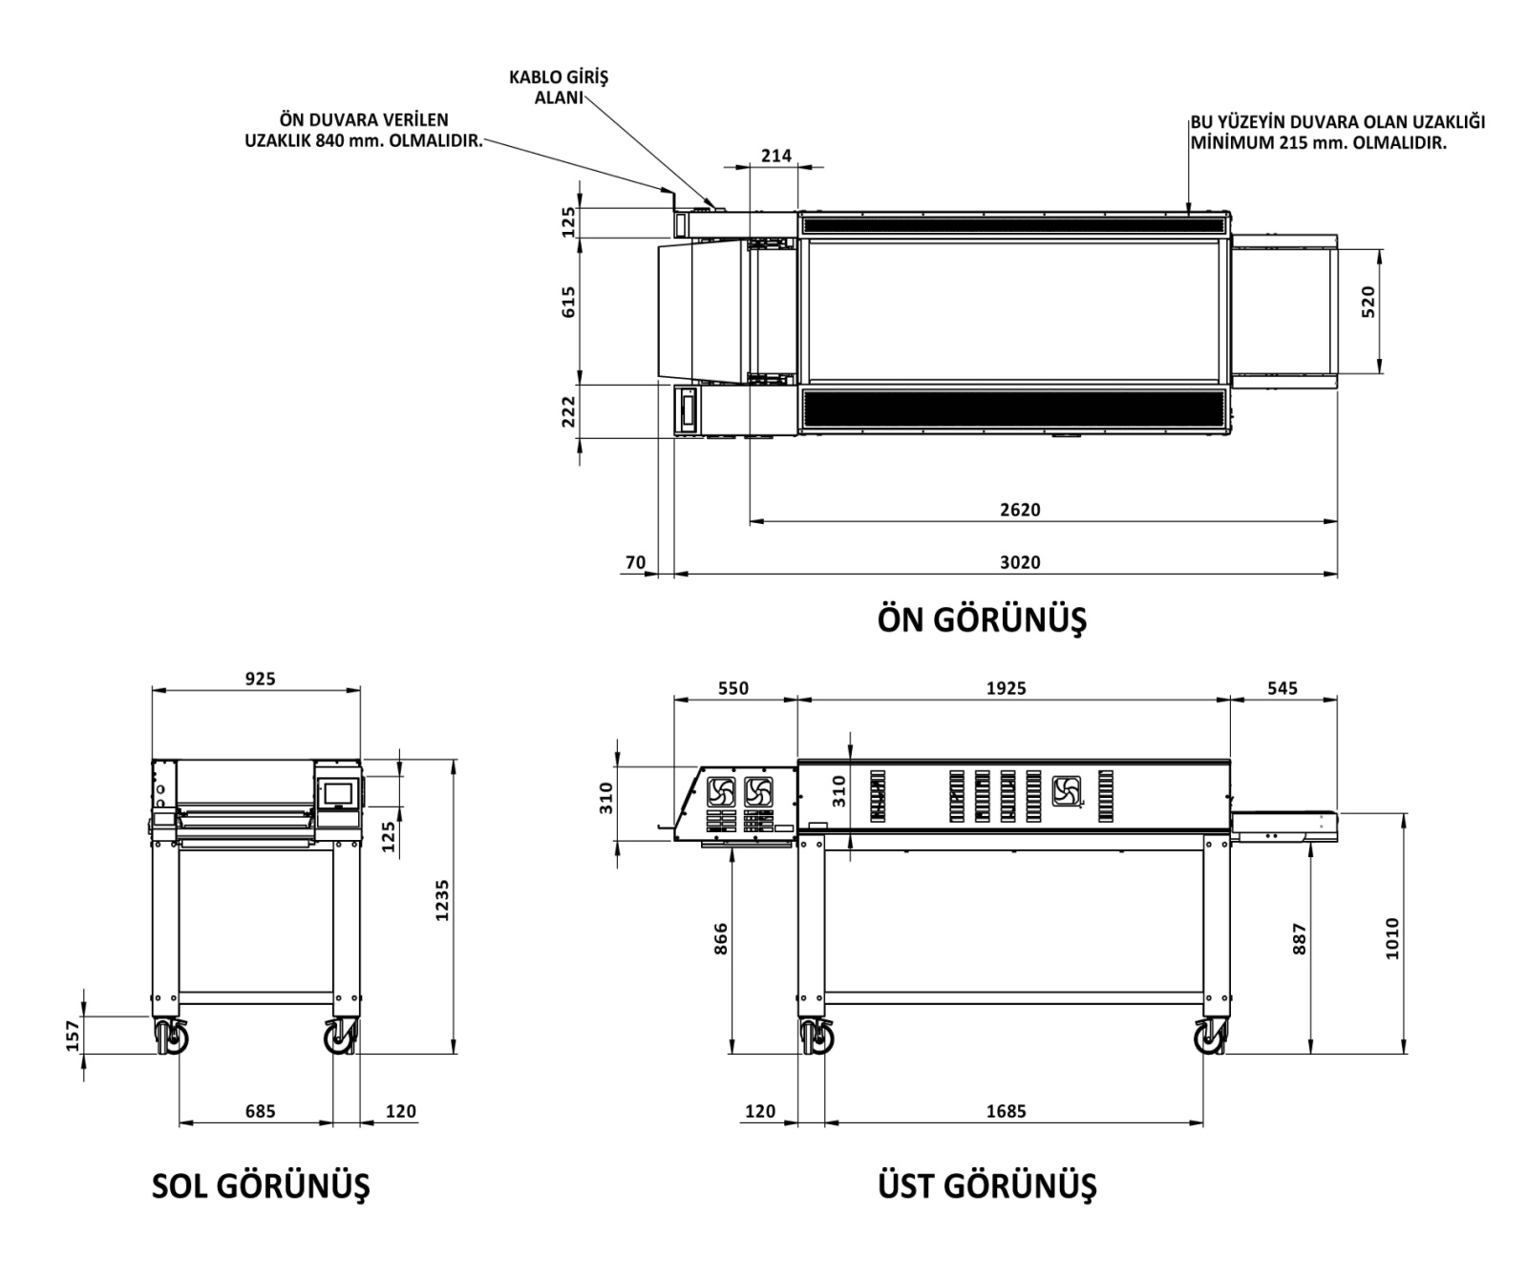
FRONT WALL DISTANCE 840 mm
POWER CABLE
INPUT

LEFT
FRONT
TOP
WALL DISTANCE IN THIS SECTION MIN. 215 mm

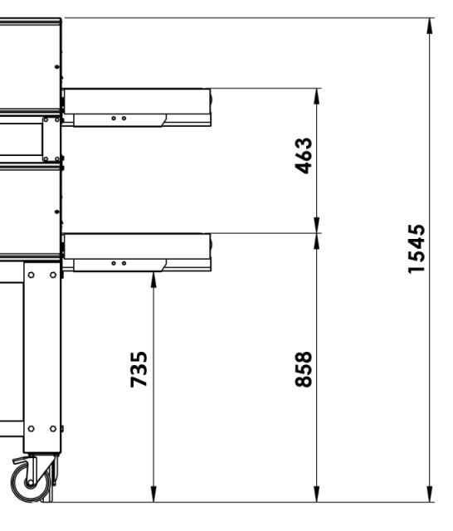
DOUBLE FLOOR OVEN

SECTION 2: MOUNTING
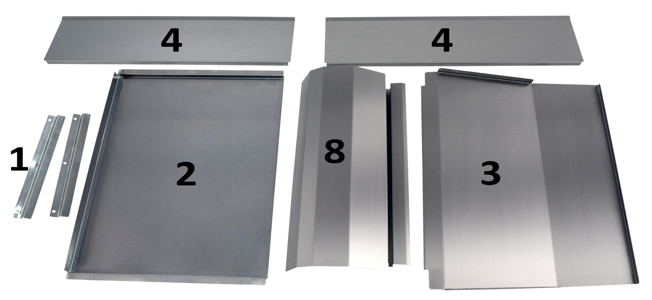

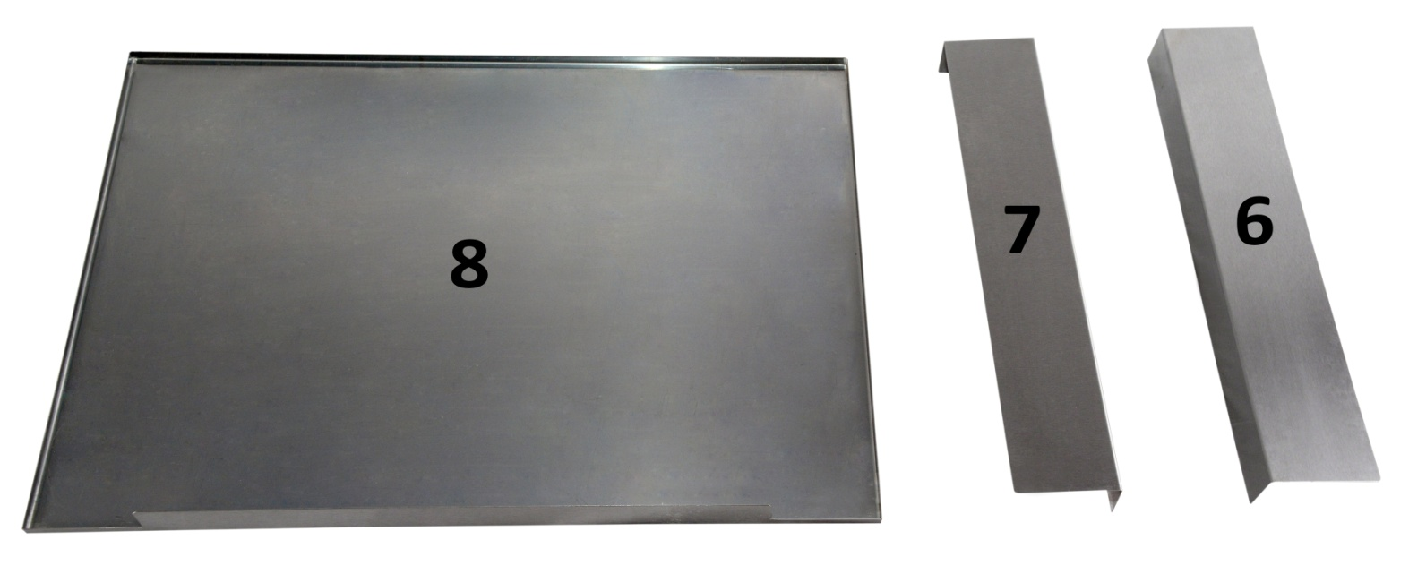

No | Part Name | Quantity
1 | Front Residuals Collection Sheet Slide | 2
2 | Front Residuals Collection Sheet | 1
3 | Front Product Extraction Sheet | 1
4 | Extraction Panel (Front and Rear) | 2
5 | Rear Residuals Collection Sheet | 1
6 | Rear Side - Bearing Protection Sheet (Left) | 1
7 | Rear Side - Bearing Protection Sheet (Right) | 1
8 | Belt Cleaner Sheet | 1

2.1Front Residuals Collection Sheet Slide (Right and Left):
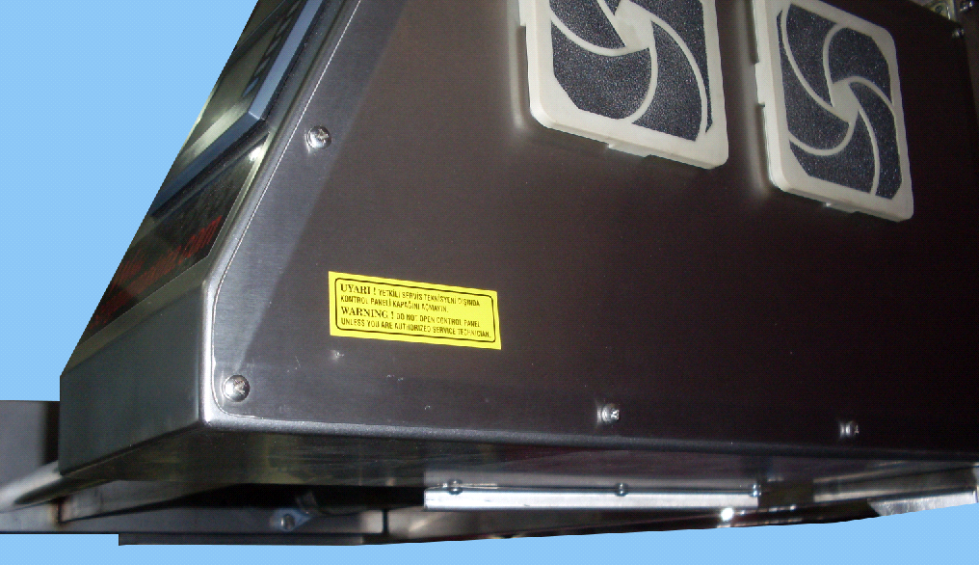
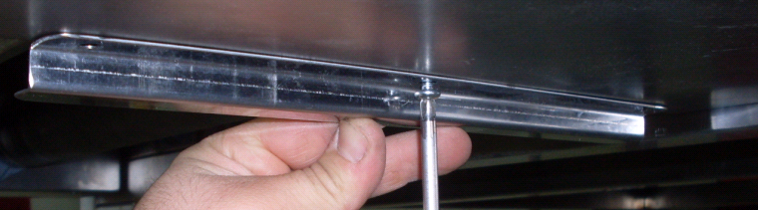

Right and left slides are mounted as illustrated in order to fix the front residual collection sheet.

2.2 Front Residuals Collection Sheet :

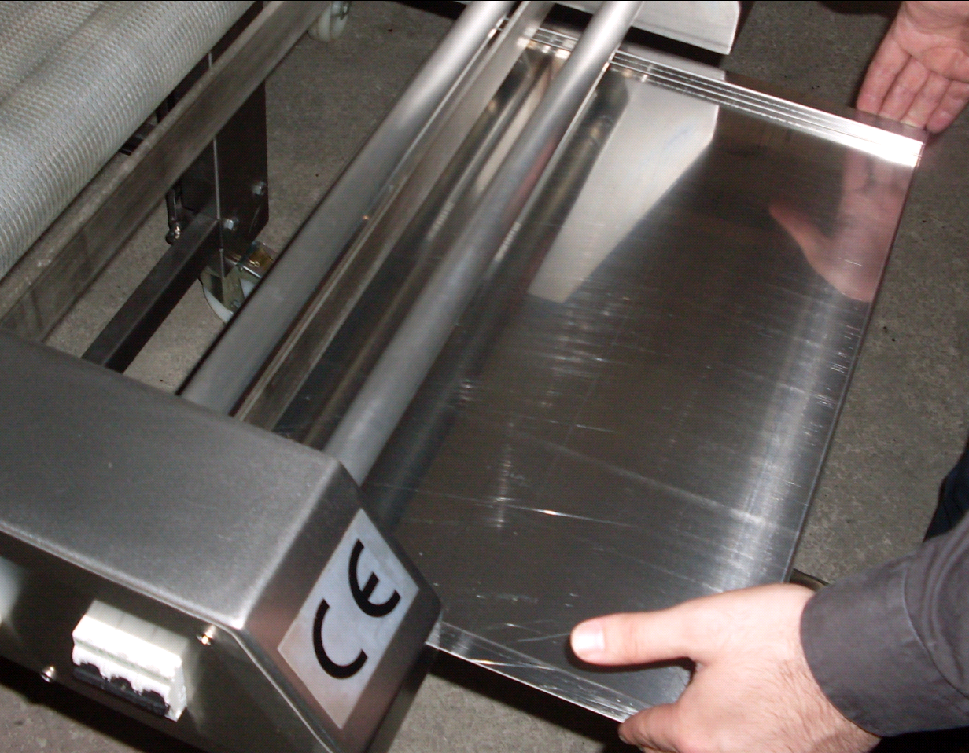

Front residual sheet is driven to the BOTTOM slides.

2.3 Front Product Extraction Sheet:
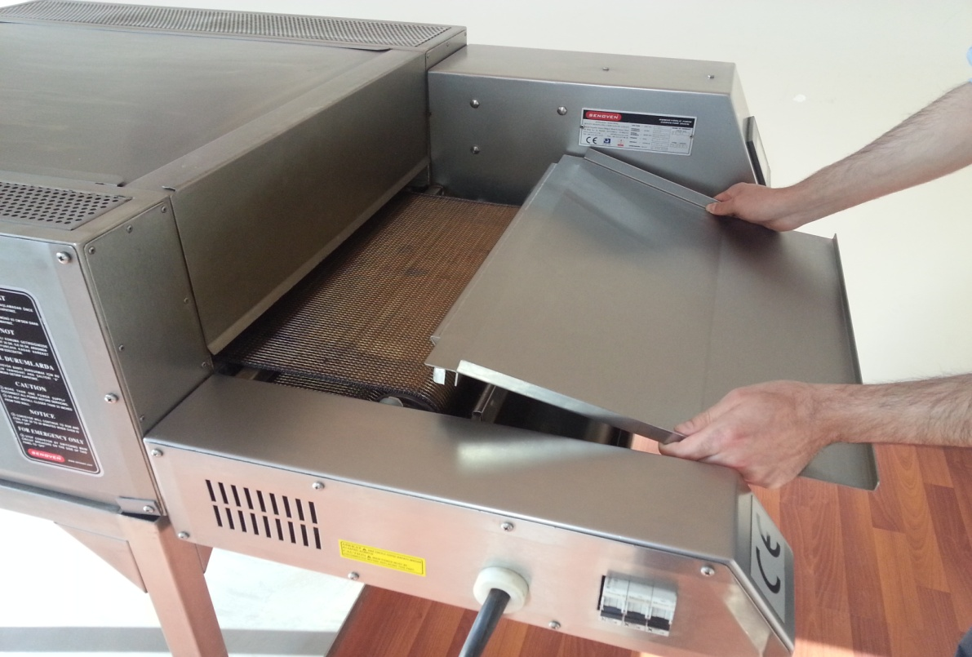

Front product extraction sheet is mounted by spreading the right and left side grooves through the sheet bar in front of the belt drum.
2.4 Extraction Panel (Front and Rear):
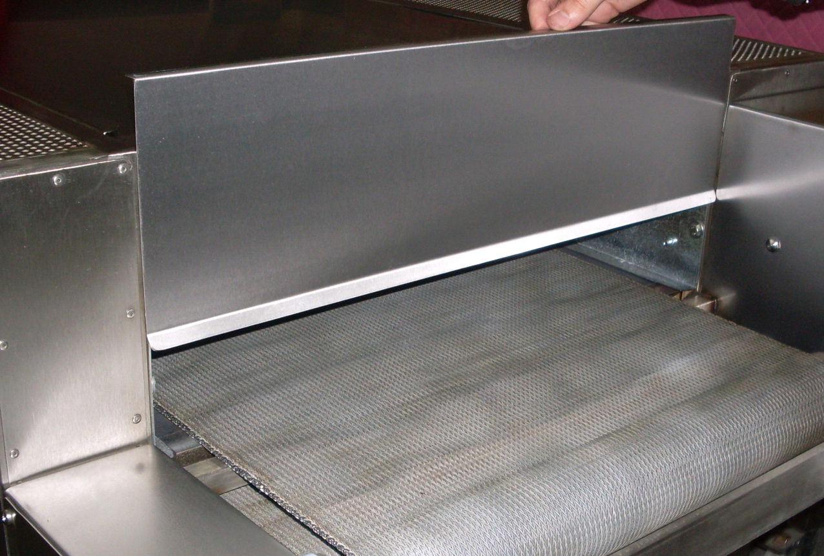

Extraction panel sheets are mounted into the front and rear oven chamber inserts in order to keep the heat loss into the oven at minimum level.

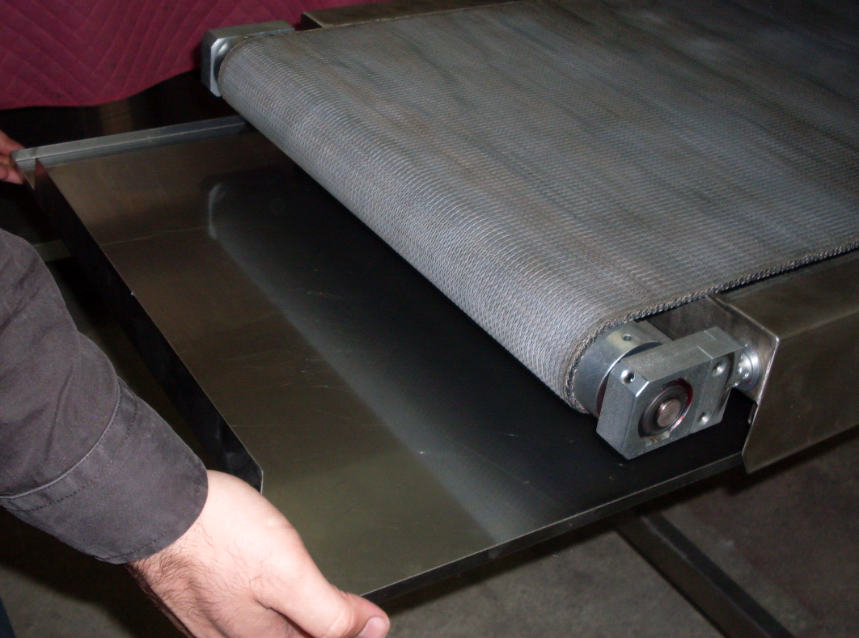
2.5 Rear Waste Collection Sheet:

Rear residual collection sheet is driven to the BOTTOM slides.

2.6 Rear Side Protection Sheet (Right and Left):
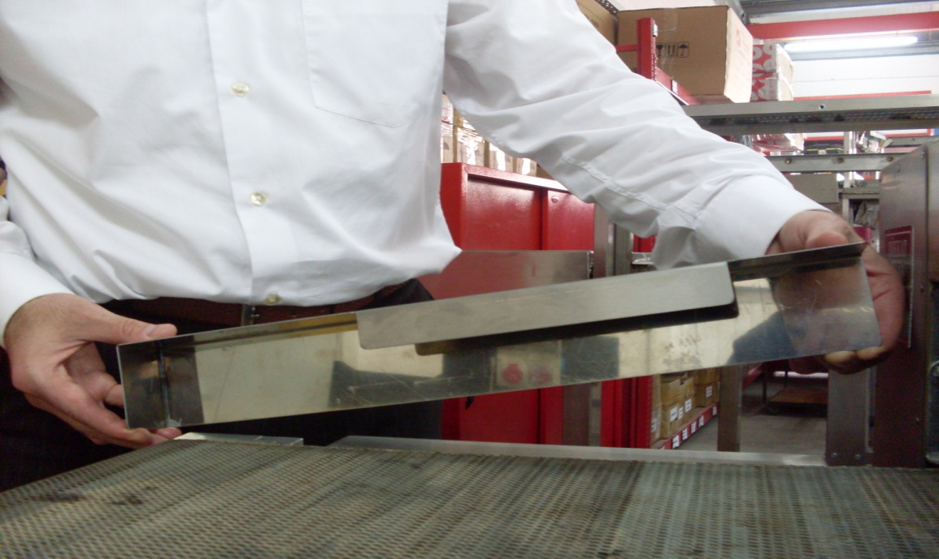

Rear side, right and left protection sheets are mounted as in the picture.

2.7 Rear Bearing Protection Sheet (Right and Left):
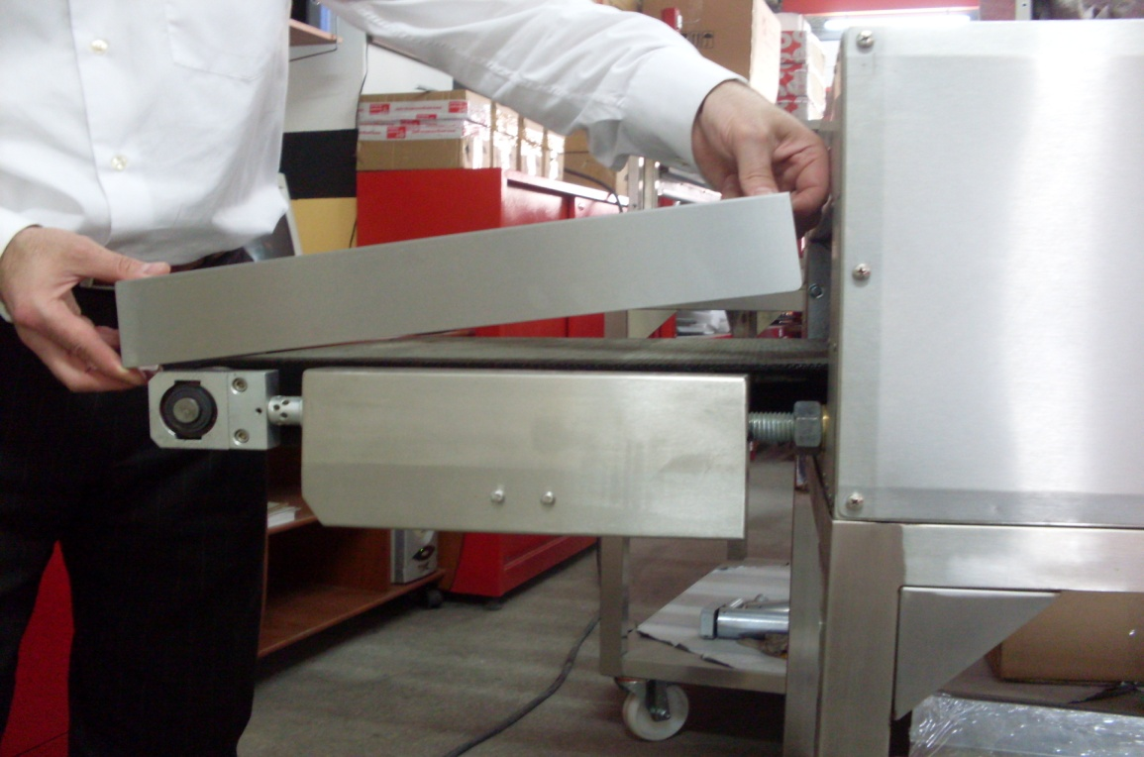

Rear side, right and left protection sheets are mounted as in the figure.
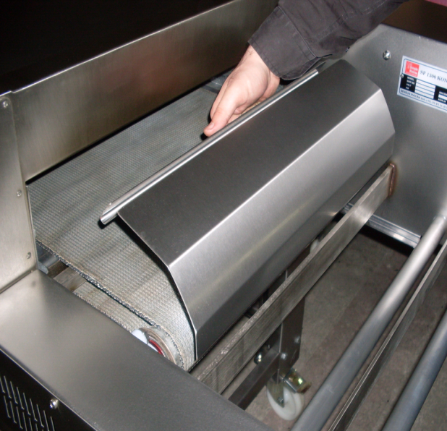
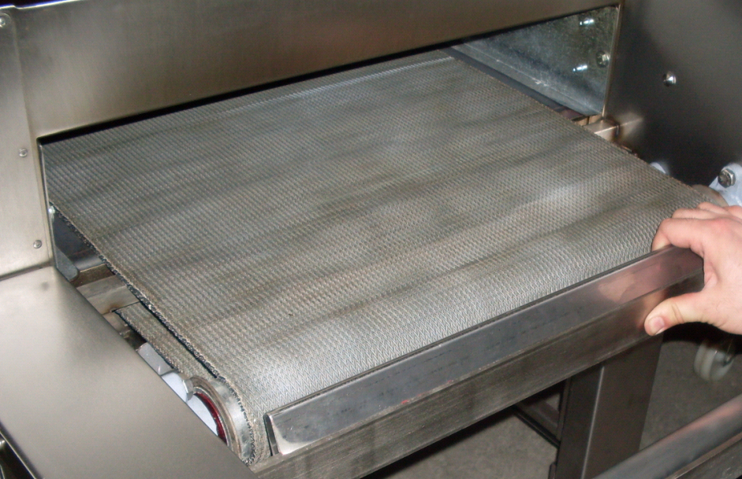
2.8 Belt Cleaner Sheet:

Belt cleaner sheet is fitted to the BOTTOM part of the belt drum from its front. The belt corrugated part of the cleaner sheet is fitted to the sheet bar in front of the drum.

2.9 High Chassis Assembly:
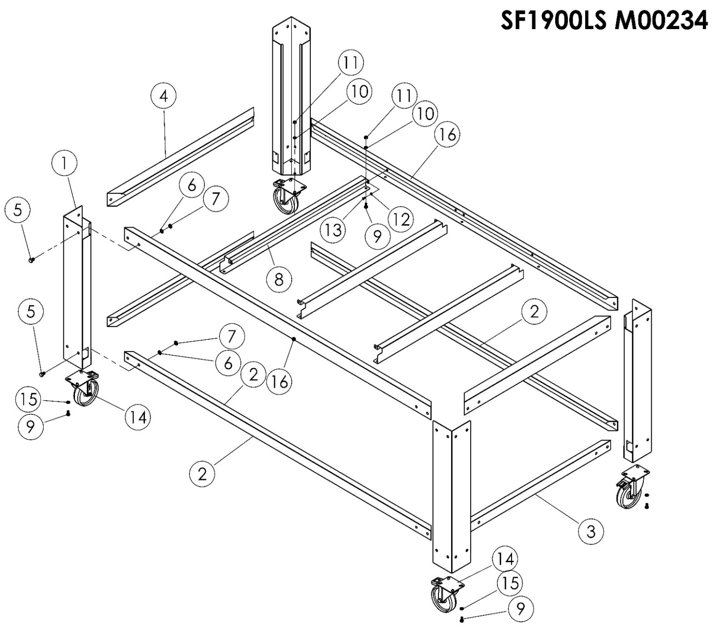
ITEM NO | SPARE PART NO | SPARE PART DESCRIPTION | QUANTITY
1 | 01457 | CHASSIS STAND SHEET | 4
2 | 01466 | ANGLE BRACKET | 2
3 | 01451 | ANGLE BRACKET | 2
4 | 01454 | ANGLE BRACKET | 2
5 | 01958 | BOLT | 32
6 | 01960 | WASHER | 32
7 | 01965 | NUT | 32
8 | 01453 | ANGLE BRACKET | 3
9 | 01957 | BOLT | 22
10 | 01961 | WASHER | 22
11 | 01959 | NUT | 22
12 | 00051 | WASHER | 6
13 | 00048 | BOLT | 6
14 | 01964 | WHEEL | 4
15 | 01963 | WASHER | 16
16 | 01491M | ANGLE BRACKET | 2

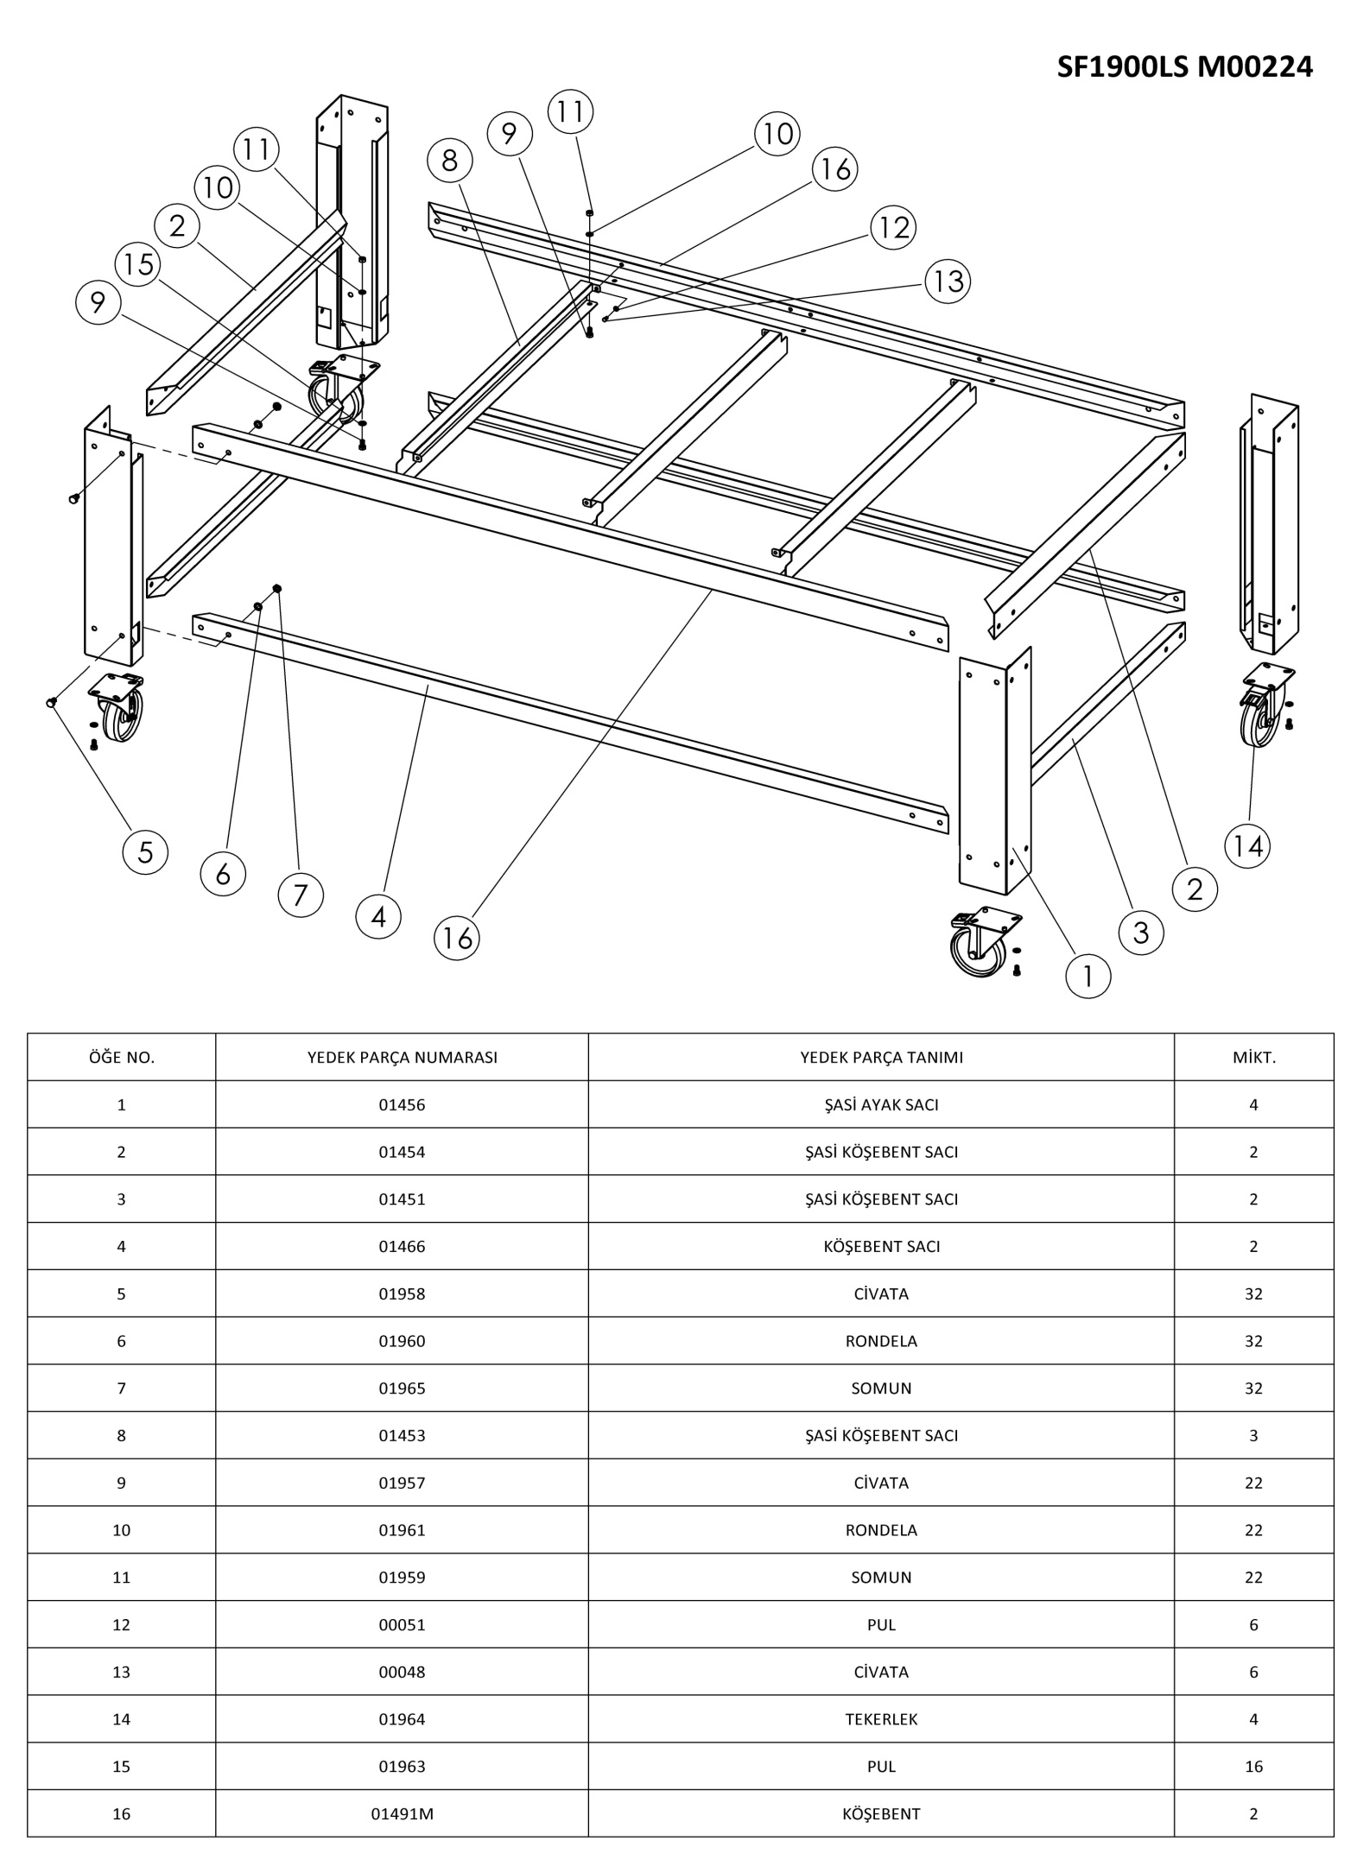
2.10 Low Chassis Assembly:

ITEM NO SPARE PART NO SPARE PART DESCRIPTION QUANTITY
CHASSIS STAND SHEET
CHASSIS ANGLE SHEET
CHASSIS ANGLE SHEET
ANGLE SHEET
BOLT
WASHER
NUT
CHASSIS ANGLE SHEET
BOLT
WASHER
NUT
WASHER
BOLT
WHEEL
WASHER
ANGLE BRACKET

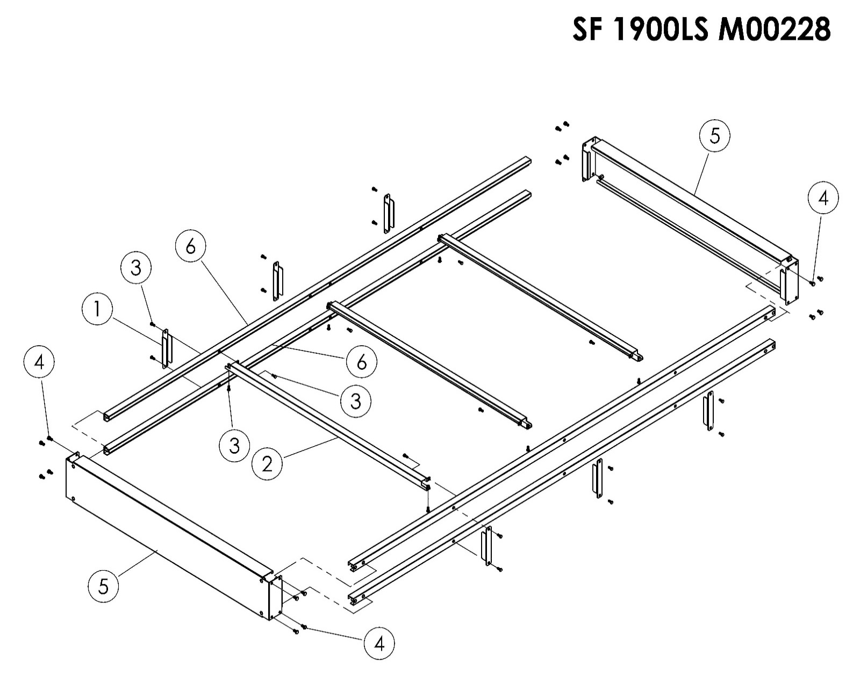
2.11 Middle Chassis Assembly:

ITEM NO | SPARE PART NO | SPARE PART DESCRIPTION | QUANTITY
1 | 01476 | INTERMEDIATE CHASSIS SIDE POST | 6
2 | 01193M | INTERMEDIATE CHASSIS ANGLE BRACKET | 3
3 | 01486 | BOLT | 24
4 | 01556 | BOLT | 16
5 | 01493M | ANGLE BRACKET | 2
6 | 1441M | ANGLE BRACKET | 4

2.12 Chassis-Oven Assembly:

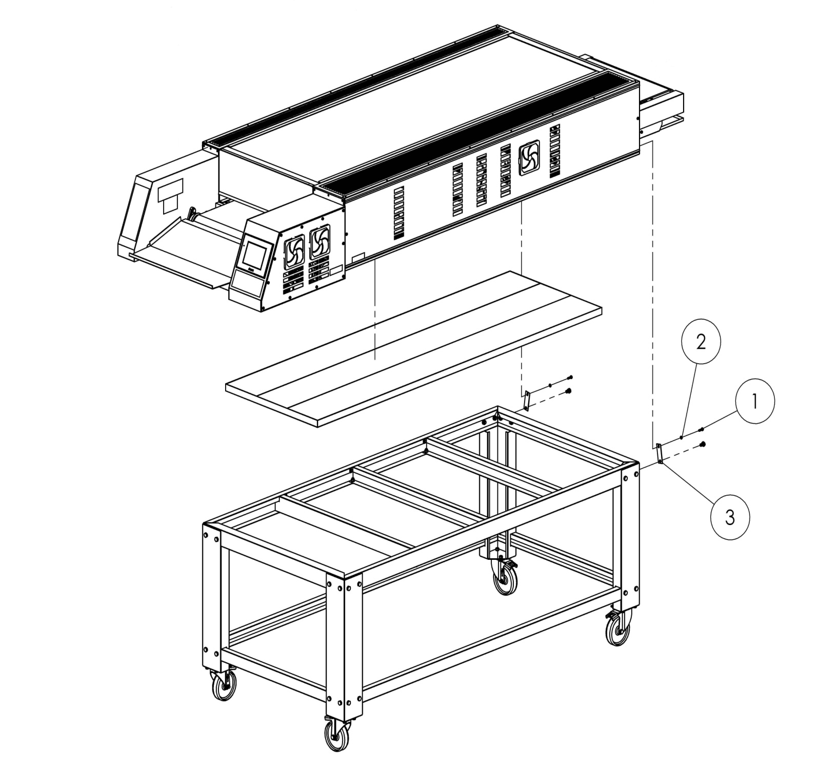

ITEM NO | SPARE PART NO | SPARE PART DESCRIPTION | QUANTITY
1 | 00041 | BOLT | 2
2 | 00042 | WASHER | 2
3 | 01241 | SHEET BAR | 2

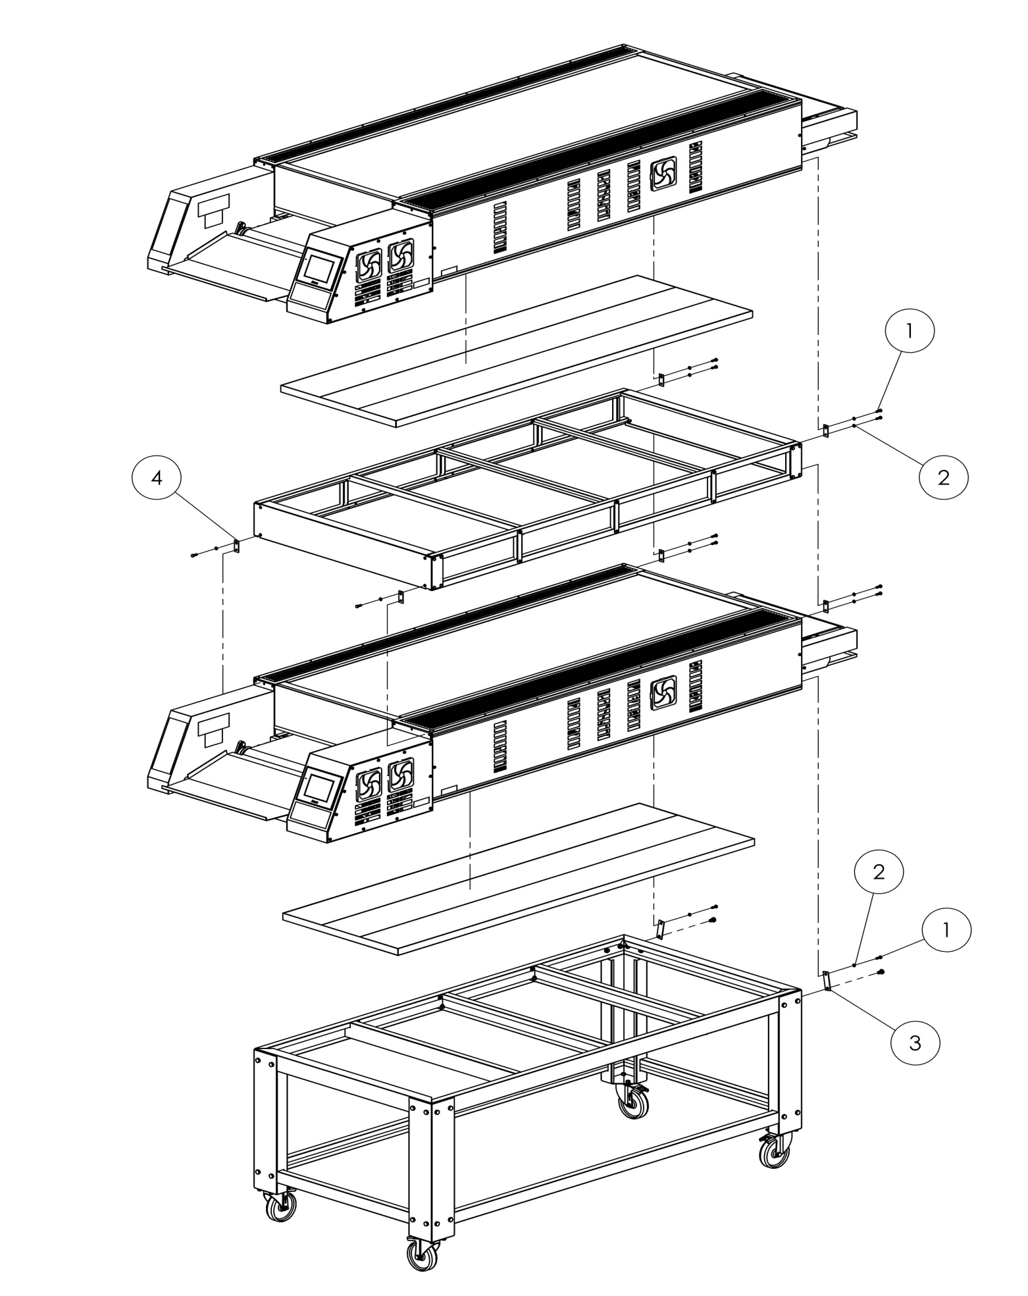
2.13 Double Floor Oven Assembly:

ITEM NO | SPARE PART NO | SPARE PART DESCRIPTION | QUANTITY
1 | 00041 | BOLT | 12
2 | 00042 | WASHER | 12
3 | 01241 | SHEET BAR | 6
4 | 01498 | SHEET BAR | 2

SECTION 3: INSTRUCTIONS FOR USE
3.1 Ventilation Recommendations:
3.1.1 Single Floor Oven:
3030
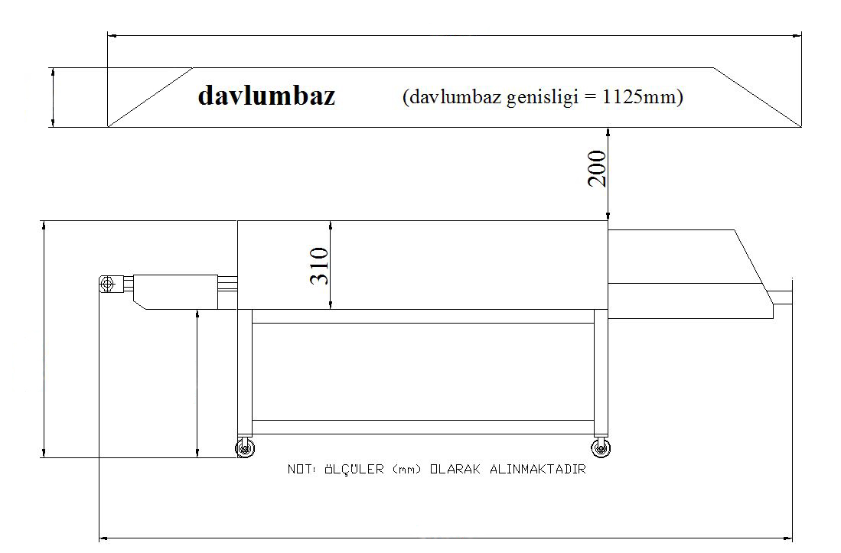

PADDLE BOX WIDTH 1125 mm
887
1234
3020

3.1.2 Double Floor Oven:
3030
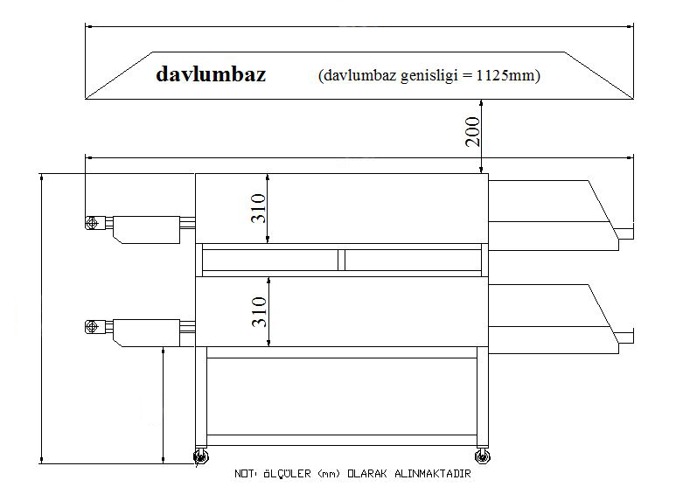

PADDLE BOX WIDTH 1125 mm
735
1545
3020

3.2 General Information about Ventilation:
Ventilation duct or extractor hood is required to have such a capacity that can absorb the heat and bad smell. A ventilation system in working condition and installed properly is the responsibility of the owner of the oven.
Ventilation inlet (extraction hood) should be in harmonization with the general ventilation and heating system.
Caution: Prevent the air flow from passing through the cooking tunnel. The air should not be directed to the front-top, side or rear part of the oven.
Now, it is time to make the energy connections of the machine. It is required to be performed by a master electricians or installer you choose.
3.3 Necessary Elements of the Installation:
In electric panel, 3 x 63 ampere (K AUTOMAT) – Fuse
Cable section is 10 mm². (TTR CABLE– 3 PHASE / 1 NEUTRAL / 1 GROUNDING)
NOTE: (TTR cable is flexible and resistant to loosening and fracturing where the oven moves here and there, forwards and backwards. Antigron cable is just the contrary. Our company prefers the TTR cable. However, antigron cable can also be used.) Grounding line can be installed from outside by using a cable of (4x10 mm²).
The cable of 5x10 mm² is required to be installed where the oven will be operated.
The grounding is required to be proper.
If the voltages are high, then a protective voltage regulator is placed.
NOTE: The conditions above are required to be fulfilled in order for the mounting of the oven to be completed properly and quickly. We expect your understanding with our best regards.

3.4 Table of the Electrical Technical Properties of the Oven SF 1900LS:
TABLE OF ELECTRIC PROPERTIES OF SF 1900LS OVEN
Voltage | Phase | N | T | Minimum Cable Section | kW | Ampere Loading
 |  |  |  |  |  | L1 | L2 | L3
400V 50/60 HZ | 3 | 1 | 1 | 10 mm² | 29,5 | 35,3 | 54 | 37,5

SF 1900LS 3 PHASE CONNECTION
TOP-1

BOTTOM-1
R
TOP-2

BOTTOM-2
S

TOP-3
BOTTOM-3
T
BOTTOM-4
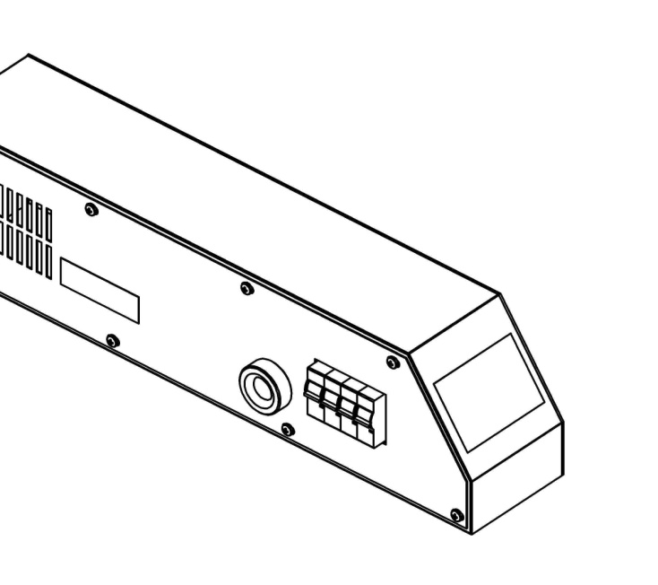

R
1
2
3
4
5
S
T
Terminal
Block
N
PE
MAIN ENERGY CABLE
INTRODUCTION

SWITCH
(FUSE)

3.5 Distance Requirements:
A space of 130 mm from the lateral surfaces is recommended. If another equipment will be placed on the right side, the distance between the equipment and the closest surface of oven is recommended to be 620 mm.
FOR ALL OVENS; 620 mm distance behind the oven is required for the operation of it.
FOR FIXED OVENS: for the ovens not moved around, a distance of 340 cm is required to be left in the right side for conveyor dismantling, maintenance, cleaning and operation.
Note: Do not install such oven(s) where the temperature is over 40 ºC. Otherwise, it may cause damage to the components of the oven(s).
Operate the oven in accordance with the instructions in terms of safety and long lifetime.
DO NOT TRY TO OPERATE THE OVEN untill the authorized service personnel or sales representative come and make all connections and check the overall system. This service makes sure that the machine connections are made properly and the system works well. The warranty starts after the proper installation is confirmed.
If the oven is operated without being controlled by the authorized service personnel or sales representative, the warranty does not start.
CAUTION! Do not stay near the belt with long hair, loose clother, pendant accessories. Getting caught in the belt may cause serious injury.

CAUTION! Do not try to operate the product if the power cord is damaged. Immediately contact the technical service or call an experienced electrician.

SECTION 4: PROGRAMMING, OPERATION AND SHUTOFF
The oven has 7 heating zones. All functions of the oven are controlled by a microprocessor. The oven is required to be programmed in advance for operation. On the following pages, it has been explained step by step with exercises. These exercises have been prepared assuming that the oven is operated for the first time after installation.
Switch over, then the operator panel opens and the logo is seen on the display.



Touch upon the logo. The cooking menu will be displayed.
LIST
0
+
−
APPLY
STOP
START
MENU
SEC
MIN
PAUSE

COOKING MENU

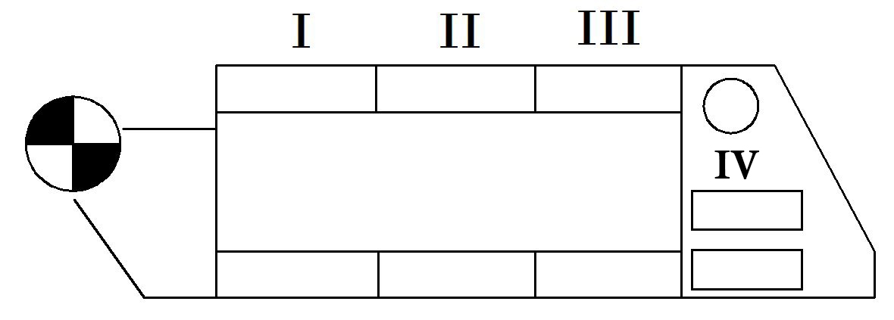

Cooking menu is not programmed in the first use. Firstly touch the MENU option to program the cooking menu. Main menu will be displayed.

LOGO
USER'S MANUAL
UTILITY PROGRAMS
COOKING PAGE
PROGRAM PAGE
MAIN MENU

ENGLISH

Touch the PROGRAM PAGE option in the main menu. Password page will be displayed.
Language option is available on this page. (Turkish-English)

PASSWORD
PLEASE, ENTER YOUR PASSWORD FOR THE PROGRAM
PASSWORD PAGE

0

MENU

Touch the box in which "0" is written on the password page. Password box will be displayed. Enter 5555 in the password box and touch the BOTTOM right enter option and wait. Program page will be displayed.

TOP HEAT

ZONE 1
sec

COOKING SETTINGS
0

BOTTOM HEAT
MENU
PROGRAM PAGE

min

ZONE 4
ZONE 3
ZONE 2

Firstly, touch the TOP left box where written "0" on the program page and set a program number. (For example 1) Then enter the name of the product you want to cook after touching the empty box on the left under the cooking settings. (For example LAHMACUN, PIDE, PIZZA etc.) And then set the cooking time by touching the minute and second boxes near the box where the name of relevant product is written. Then adjust the heat of the resistances by touching the boxes under Zone 1, Zone 2, Zone 3 and Zone 4 near the boxes of high and low heat. (There are 7 resistances in total.)
The temperature difference between the BOTTOM and top heating zones should not exceed 120 °C. Maximum temperature difference between the BOTTOM Zone 1 and Zone 2, Zone 2 and Zone 3, Zone 3 and Zone 4 should not exceed 40 °C.
Note: You can store more than one program in the memory. For this, you can include a new product (For example LAHMACUN, PIDE, PIZZA etc.) in the program by touching the box of NO on the TOP left and enter the number you want.
Touch the MENU option in the program page and return to the main menu after programming it. Touch the COOKING PAGE option in the main menu and return to the cooking menu.

+
2
−
MENU
30
3
COOKING MENU

MIN SEC
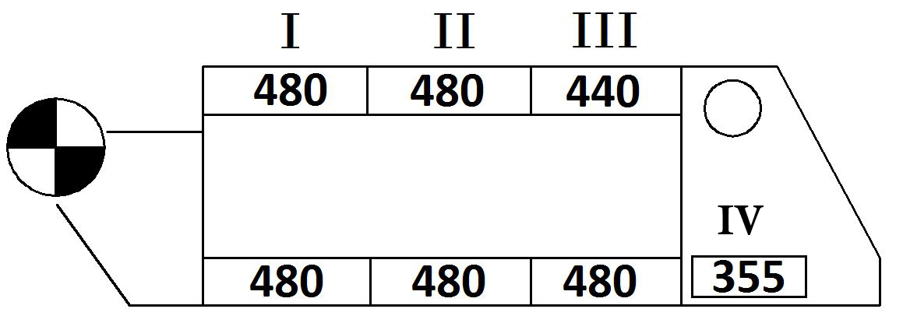

PIDE

PAUSE

APPLY
STOP
START
LIST

Choose the program number of the product you want to cook among the + and – options in the cooking menu. (For example 2 = PIDE) then touch the APPLY option. After the program values of the product are displayed on the screen, then touch the START option to operate the oven. When it starts working, the resistances start to hot up and the belt starts to move. When the resistances get hot enough, the statement of OVEN IS READY TO COOK will be displayed. You can put the product into the oven when you see this statement.
Note: While the product is being cooked in the oven, if the PAUSE option is selected, the belt stops but the heating coils go on working and the product is kept into the oven. If the product is preferred to be overcooked (crispy), this option can be selected. To exit this option, PAUSE button is pushed again.
The list menu is used to see the programmed products in a list with the program numbers. For doing this, touch the LIST option in the cooking menu. The product to be cooked is selected from the list by touching the program number.

MENU
LAHMACUN
1
PIDE
2
L
I
S
T

TIRNAK
3
4
PIZZA
TOMBIK
5
FISH
6
MEATBALL
7
2

4.1 Utility Programs:
Touch the UTILITY PROGRAMS option in the main menu. The mode of operation menu will be displayed.

MENU

MODE OF OPERATION
STANDBY MODE
CLEANING PROGRAM
MANUAL OPERATION

4.2 Manual Operation:
Touch the MANUAL OPERATION option in the mode of operation menu. Password page will be displayed. Touch the box in which "0" is written on the password page. Password box will be displayed. Enter 4444 in the password box and touch the BOTTOM right enter option and wait. Program page will be displayed.

MENU
MANUAL PAGE

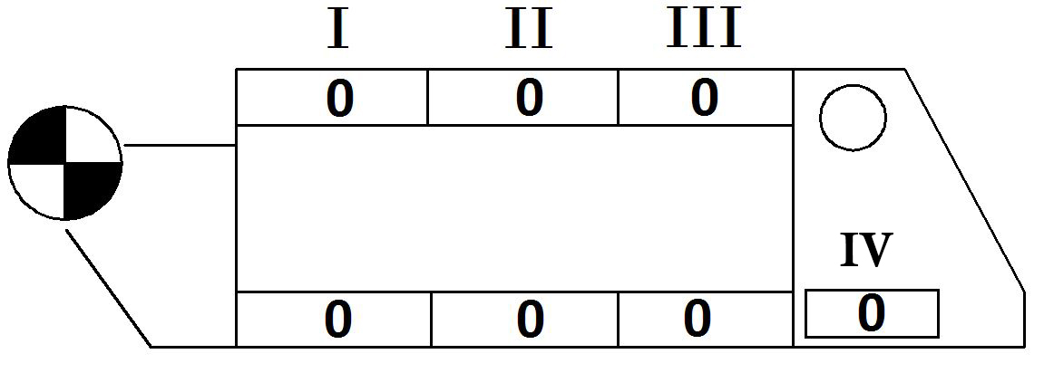
0
0
COOKING

sec
min

STOP
START
APPLY

On the manual page, you can easily include an unprogrammed product you want to cook in the program Firstly, touch the min and sec options to set the cooking time. Then adjust the heat of the heating coils by touching the boxes under I, II, III and IV and touch the APPLY option and the START option to start the cooking. In this option, all functions will instantly response to you.
4.3 Cleaning Program:
Touch the CLEANING PROGRAM option in the mode of operation menu. The statement of OVEN WORKS IN CLEANING PROGRAM is displayed. In cleaning program, the heating coils burn up the residuals in the oven at high temperature and help them to accumulate on the front and rear residual collection sheets with belt cleaner. When necessary, exit the cleaning program by touching the EXIT CLEANING PROGRAM option. The device continue to work in this program for 50 minutes unless the button of EXIT CLEANING PROGRAM is pushed.

4.4 Standby Mode:
Touch the STANDBY MODE option in the mode of operation menu. The statement of OVEN WORKS IN STANDBY MODE is displayed. The oven consume 25% less energy in standby mode. It ensures that the oven stands ready at certain intervals. When necessary, you can exit the standby mode by touching the EXIT STANDBY MODE option.
4.5 Warnings:
1. When the limit values determined by the manufacturer for the top and BOTTOM heating zones, the devices gives the warning of the TEMPERATURE LIMIT EXCEEDED.
2. If the product is not cooked, check the cooking times and heat settings. The CONVEYOR may be turning fast.
3. If the product is overcooked, check the cooking times and heat settings. The conveyor may be slow.
4. If the product is overcooked or not cooked although all values are normal, then contact the manufacturing company.
4.6 Shutdown:
The belt continues to operate until the temperature of each heating coil drops below 200°C after touching the STOP option to shut down the oven in working condition. After the temperature of the heating coils drops below 200°C CAUTION!!! TURN OFF THE SWITCH will be displayed. You can shut down the oven by turning of the switch when you see this warning.
You can also directly turn of the switch to shut down the oven. However, the temperature is dropped below 200°C to damp the expansion tension gradually. This minimizes the damage to the machine and the belt.

SECTION 5: TYPES OF FOOD
5.1 Some of Products Cooked in the Oven:
- Seefood Kebab
- Pastry
- Bagel
- Bread Sticks
- Whole Wheat Bread
- Wheat (Corn) Bread
- Fresh Bread
- Garlic Bread
- Cakes
- Soft Bagels
- Toast
- Tırnak
- Tombik
- Buns
- Pasty
- Lavash
- Beef
- Beef Rib
- Hamburger
- Liver and Onions
- Meatballs
- Beefsteak
- Strip Steak
- Steak Fillet (Whole)
- Sausage
- Sausage Pasty
- Casserole
- Lasagna
- Macaroni and Cheese
- Macaroni and Sauce
- Cookies
- Cake
- Chocolate
- Macarons
- Oatmeal
- Desserts
- Apple Dessert
- Cooked Pudding
- Cream Cake
- Fruit Cake
- Layer Cake
- Meringue Cake
- Puff Pasty
- Appetizers
- Chips
- Oysters
- Fish and Seafood
- Lobster Tail
- Shrimp
- Crab
- White Meat Fish Fillets
- Whole Trout
- Pizza
- Frozen Pizza
- Thick Crust
- Thin Crust
- Llahmacun
- Poultry
- Chicken Cordon Blue
- Chicken Flakes
- Half Chicken
- Whole Chicken
- Breakfast Food
- Beef Pastirma
- Biscuits
- Egg Burrito
- Fried Egg
- Fluffy Omelet
- Sujuk

5.2 Sample Cooking Programs:

LAHMACUN TOP ZONE 1 TOP ZONE 2 TOP ZONE 3 INTRODUCTION MEDIUM EXIT
-ON BELT
-FRESH

TIME

2 min. 10 sec.

LESS INTENSE

455 ℃ | 455 ℃ | 475 ℃
355 °C | 365 ℃ | 375 ℃ | 375 ℃

INTRODUCTION MEDIUM EXIT LAST EXIT
BOTTOM ZONE 1 BOTTOM ZONE 2 BOTTOM ZONE 3 BOTTOM ZONE 4
LAHMACUN TOP ZONE 1 TOP ZONE 2 TOP ZONE 3 INTRODUCTION MEDIUM EXIT
-ON BELT
-FRESH

TIME

2 min. 20 sec.

NORMAL

460 ℃ | 470 ℃ | 480 ℃
360 °C | 370 °C | 380 ℃ | 380 ℃

INTRODUCTION MEDIUM EXIT LAST EXIT
BOTTOM ZONE 1 BOTTOM ZONE 2 BOTTOM ZONE 3 BOTTOM ZONE 4

LAHMACUN TOP ZONE 1 TOP ZONE 2 TOP ZONE 3 INTRODUCTION MEDIUM EXIT
-ON BELT
-FRESH

TIME

2 min. 30 sec.

INTENSE

470 ℃ | 480 ℃ | 482 °C
370 °C | 380 ℃ | 382 ℃ | 382 ℃

INTRODUCTION MEDIUM EXIT LAST EXIT
BOTTOM ZONE 1 BOTTOM ZONE 2 BOTTOM ZONE 3 BOTTOM ZONE 4LAHMACUN TOP ZONE 1 TOP ZONE 2 TOP ZONE 3 INTRODUCTION MEDIUM EXIT
-ON BELT
-FRESH

TIME

3 min.

VERY INTENSE

475 ℃ | 480 ℃ | 485 °C
375 ℃ | 380 ℃ | 385 ℃ | 385 ℃

INTRODUCTION MEDIUM EXIT LAST EXIT
BOTTOM ZONE 1 BOTTOM ZONE 2 BOTTOM ZONE 3 BOTTOM ZONE 4
PIDE / PIZZA TOP ZONE 1 TOP ZONE 2 TOP ZONE 3 INTRODUCTION MEDIUM EXIT
-ON BELT
-FRESH

TIME

6 min.

320 °C | 340 ℃ | 360 °C
315 ℃ | 280 °C | 315 ℃ | 315 ℃

INTRODUCTION MEDIUM EXIT LAST EXIT
BOTTOM ZONE 1 BOTTOM ZONE 2 BOTTOM ZONE 3 BOTTOM ZONE 4
TIRNAK / TOMBIK TOP ZONE 1 TOP ZONE 2 TOP ZONE 3 INTRODUCTION MEDIUM EXIT
-ON BELT
-FRESH

TIME

4 min.

455 ℃ | 465 °C | 475 ℃
355 °C | 365 ℃ | 375 ℃ | 375 ℃

INTRODUCTION MEDIUM EXIT LAST EXIT
BOTTOM ZONE 1 BOTTOM ZONE 2 BOTTOM ZONE 3 BOTTOM ZONE 4
BUNS TOP ZONE 1 TOP ZONE 2 TOP ZONE 3 INTRODUCTION MEDIUM EXIT
TIME

8 min.
-ALUMINIUM PAN
-FRESH

200 °C | 200 °C | 200 °C
200 °C | 200 °C | 200 °C | 200 °C

INTRODUCTION MEDIUM EXIT LAST EXIT
BOTTOM ZONE 1 BOTTOM ZONE 2 BOTTOM ZONE 3 BOTTOM ZONE 4

LOBSTER TAIL TOP ZONE 1 TOP ZONE 2 TOP ZONE 3 INTRODUCTION MEDIUM EXIT
TIME

2 min. 10 sec.

LESS INTENSE

-ON BELT
-FRESH

454 °C | 426 °C | 426 °C
315 °C | 287 °C | 260 ℃ | 260 ℃

INTRODUCTION MEDIUM EXIT LAST EXIT
BOTTOM ZONE 1 BOTTOM ZONE 2 BOTTOM ZONE 3 BOTTOM ZONE 4
SHRIMPS TOP ZONE1 TOP ZONE 2 TOP ZONE 3 INTRODUCTION MEDIUM EXIT
-ON BELT
-FRESH

TIME

2 min. 20 sec.

NORMAL

454 ℃ | 426 °C | 426 °C
260 °C | 287 ℃ | 315 °C | 315 °C

INTRODUCTION MEDIUM EXIT LAST EXIT
BOTTOM ZONE 1 BOTTOM ZONE 2 BOTTOM ZONE 3 BOTTOM ZONE 4

CRAB TOP ZONE 1 TOP ZONE 2 TOP ZONE 3 INTRODUCTION MEDIUM EXIT
-ON BELT
-FRESH

TIME

2 min. 30 sec.

INTENSE

454 ℃ | 426 °C | 426 °C
260 °C | 287 °C | 315 ℃ | 260 °C

INTRODUCTION MEDIUM EXIT LAST EXIT
BOTTOM ZONE 1 BOTTOM ZONE 2 BOTTOM ZONE 3 BOTTOM ZONE 4
WHITE MEAT FISH FILLETS TOP ZONE 1 TOP ZONE 2 TOP ZONE 3 INTRODUCTION MEDIUM EXIT
-ON BELT
-FRESH

TIME

3 min.

VERY INTENSE

454 ℃ | 426 °C | 426 °C
315 ℃ | 287 °C | 260 °C | 260 °C

INTRODUCTION MEDIUM EXIT LAST EXIT
BOTTOM ZONE 1 BOTTOM ZONE 2 BOTTOM ZONE 3 BOTTOM ZONE 4

WHOLE TROUT TOP ZONE 1 TOP ZONE 2 TOP ZONE 3 INTRODUCTION MEDIUM EXIT
-ON BELT
-FRESH

TIME

6 min.

454 ℃ | 426 °C | 426 °C
260 °C | 287 °C | 315 °C | 315 °C

INTRODUCTION MEDIUM EXIT LAST EXIT
BOTTOM ZONE 1 BOTTOM ZONE 2 BOTTOM ZONE 3 BOTTOM ZONE 4

FROZEN PİZZA TOP ZONE 1 TOP ZONE 2 TOP ZONE 3 INTRODUCTION MEDIUM EXIT
-ON BELT
-FRESH

TIME

4 min.

454 ℃ | 398 °C | 343 °C
260 °C | 274 ℃ | 287 °C | 287 °C

INTRODUCTION MEDIUM EXIT LAST EXIT
BOTTOM ZONE 1 BOTTOM ZONE 2 BOTTOM ZONE 3 BOTTOM ZONE 4
THICK CRUST PİZZA TOP ZONE 1 TOP ZONE 2 TOP ZONE 3 INTRODUCTION MEDIUM EXIT
TIME

8 min.
-ALUMINIUM PAN
-FRESH

454 ℃ | 426 °C | 398 °C
287 °C | 301 °C | 315 °C | 315 °C

INTRODUCTION MEDIUM EXIT LAST EXIT
BOTTOM ZONE 1 BOTTOM ZONE 2 BOTTOM ZONE 3 BOTTOM ZONE 4

THIN CRUST PİZZA TOP ZONE TOP ZONE 2 TOP ZONE 3 INTRODUCTION MEDIUM EXIT
TIME

8 min.

-ALUMINIUM PAN
-FRESH
454 ℃ | 426 °C | 398 °C
260 °C | 274 ℃ | 287 °C | 287 °C

INTRODUCTION MEDIUM EXIT LAST EXIT
BOTTOM ZONE 1 BOTTOM ZONE 2 BOTTOM ZONE 3 BOTTOM ZONE 4

CHICKEN GORDON BLUE TOP ZONE 1 TOP ZONE 2 TOP ZONE 3
-ON BELT
-FRESH

TIME

2 min. 10 sec.

LESS INTENSE

INTRODUCTION MEDIUM EXIT
426 °C | 370 °C | 343 °C
260 °C | 274 ℃ | 287 °C | 287 °C

INTRODUCTION MEDIUM EXIT LAST EXIT
BOTTOM ZONE 1 BOTTOM ZONE 2 BOTTOM ZONE 3 BOTTOM ZONE 4
CHICKEN FLAKES TOP ZONE 1 TOP ZONE 2 TOP ZONE 3 INTRODUCTION MEDIUM EXIT
-ON BELT
-FRESH

TIME

2 min. 20 sec.

NORMAL

426 °C | 370 °C | 343 °C
260 °C | 274 ℃ | 287 °C | 287 °C

INTRODUCTION MEDIUM EXIT LAST EXIT
BOTTOM ZONE 1 BOTTOM ZONE 2 BOTTOM ZONE 3 BOTTOM ZONE 4

HALF CHICKEN TOP ZONE 1 TOP ZONE 2 TOP ZONE 3 INTRODUCTION MEDIUM EXIT
-ON BELT
-FRESH

TIME

2 min. 30 sec.

INTENSE

426 °C | 370 °C | 343 °C
260 °C | 274 ℃ | 260 °C | 260 °C

INTRODUCTION MEDIUM EXIT LAST EXIT
BOTTOM ZONE 1 BOTTOM ZONE 2 BOTTOM ZONE 3 BOTTOM ZONE 4
WHOLE CHICKEN TOP ZON TOP ZONE 2 TOP ZONE 3 INTRODUCTION MEDIUM EXIT
-ON BELT
-FRESH

TIME

3 min.

VERY INTENSE

398 °C | 370 °C | 343 °C
260 °C | 274 °C | 287 ℃ | 287 ℃

INTRODUCTION MEDIUM EXIT LAST EXIT
BOTTOM ZONE 1 BOTTOM ZONE 2 BOTTOM ZONE 3 BOTTOM ZONE 4

BEEF PASTIRMA TOP ZONE 1 TOP ZONE 2 TOP ZONE 3 INTRODUCTION MEDIUM EXIT
-ON BELT
-FRESH

TIME

6 min.

398 °C | 370 °C | 343 °C
260 °C | 287 ℃ | 287 ℃ | 287 ℃

INTRODUCTION MEDIUM EXIT LAST EXIT
BOTTOM ZONE 1 BOTTOM ZONE 2 BOTTOM ZONE 3 BOTTOM ZONE 4
BISCUIT TOP ZONE 1 TOP ZONE 2 TOP ZONE 3 INTRODUCTION MEDIUM EXIT
-ON BELT
-FRESH

TIME

4 min.

370 °C | 315 °C | 301 °C
260 °C | 287 ℃ | 287 ℃ | 287 ℃

INTRODUCTION MEDIUM EXIT LAST EXIT
BOTTOM ZONE 1 BOTTOM ZONE 2 BOTTOM ZONE 3 BOTTOM ZONE 4

EGG BURRITO TOP ZONE 1 TOP ZONE 2 TOP ZONE 3 INTRODUCTION MEDIUM EXIT
TIME

8 min.
-ALUMINIUM PAN
-FRESH

370 °C | 315 °C | 301 °C
260 °C | 287 °C | 287 °C | 287 °C

INTRODUCTION MEDIUM EXIT LAST EXIT
BOTTOM ZONE 1 BOTTOM ZONE 2 BOTTOM ZONE 3 BOTTOM ZONE 4
FRIED EGG TOP ZONE 1 TOP ZONE 2 TOP ZONE 3 INTRODUCTION MEDIUM EXIT
-ALUMINIUM PAN
-FRESH
TIME

8 min.

370 ℃ | 315 °C | 301 °C
260 °C | 287 °C | 287 °C | 287 °C

INTRODUCTION MEDIUM EXIT LAST EXIT

BOTTOM ZONE 1 BOTTOM ZONE 2 BOTTOM ZONE 3 BOTTOM ZONE 4

FLUFFY OMELET TOP ZONE 1 TOP ZONE 2 TOP ZONE 3 INTRODUCTION MEDIUM EXIT
-ON BELT
-FRESH

TIME

2 min. 10 sec.

LESS INTENSE

455 ℃ | 465 °C | 475 °C
355 °C | 365 °C | 375 ℃ | 375 ℃

INTRODUCTION MEDIUM EXIT LAST EXIT
BOTTOM ZONE 1 BOTTOM ZONE 2 BOTTOM ZONE 3 BOTTOM ZONE 4
SAUSAGE TOP ZONE 1 TOP ZONE 2 TOP ZONE 3 INTRODUCTION MEDIUM EXIT
-ON BELT
-FRESH

TIME

2 min. 20 sec.

NORMAL

398 °C | 370 °C | 343 °C
260 ℃ | 287 °C | 287 °C | 287 °C

INTRODUCTION MEDIUM EXIT LAST EXIT
BOTTOM ZONE 1 BOTTOM ZONE 2 BOTTOM ZONE 3 BOTTOM ZONE 4

SAUSAGE PASTY TOP ZONE 1 TOP ZONE 2 TOP ZONE 3 INTRODUCTION MEDIUM EXIT
-ON BELT
-FRESH

TIME

2 min. 30 sec.

INTENSE

398 °C | 370 °C | 343 °C
260 °C | 287 °C | 287 °C | 287 °C

INTRODUCTION MEDIUM EXIT LAST EXIT
BOTTOM ZONE 1 BOTTOM ZONE 2 BOTTOM ZONE 3 BOTTOM ZONE 4
LASAGNA TOP ZONE 1 TOP ZONE 2 TOP ZONE 3 INTRODUCTION MEDIUM EXIT
-ON BELT
-FRESH

TIME

3 min.

VERY INTENSE

454 ℃ | 398 ℃ | 370 °C
274 °C | 287 °C | 301 °C | 301 °C

INTRODUCTION MEDIUM EXIT LAST EXIT
BOTTOM ZONE 1 BOTTOM ZONE 2 BOTTOM ZONE 3 BOTTOM ZONE 4
MACARONI AND CHEESE TOP ZONE 1 TOP ZONE 2 TOP ZONE 3 INTRODUCTION MEDIUM EXIT
-ON BELT
-FRESH

TIME

6 min.

315 °C | 287 °C | 260 °C
232 °C | 260 °C | 274 °C | 274 °C

INTRODUCTION MEDIUM EXIT LAST EXIT
BOTTOM ZONE 1 BOTTOM ZONE 2 BOTTOM ZONE 3 BOTTOM ZONE 4

MACARONI AND SAUCE TOP ZONE 1 TOP ZONE 2 TOP ZONE 3 INTRODUCTION MEDIUM EXIT
TIME

4 min.

-ON BELT
-FRESH

454 ℃ | 398 ℃ | 370 °C
274 °C | 287 °C | 301 °C | 301 °C

INTRODUCTION MEDIUM EXIT LAST EXIT
BOTTOM ZONE 1 BOTTOM ZONE 2 BOTTOM ZONE 3 BOTTOM ZONE 4
CAKE TOP ZONE 1 TOP ZONE 2 TOP ZONE 3 INTRODUCTION MEDIUM EXIT
TIME

8 min.
-ALUMINIUM PAN
-FRESH

370 °C | 287 °C | 260 °C
260 °C | 274 °C | 287 °C | 287 °C

INTRODUCTION MEDIUM EXIT LAST EXIT
BOTTOM ZONE 1 BOTTOM ZONE 2 BOTTOM ZONE 3 BOTTOM ZONE 4
CHOCOLATE TOP ZONE 1 TOP ZONE 2 TOP ZONE 3 INTRODUCTION MEDIUM EXIT
-ALUMINIUM PAN
-FRESH
TIME

8 min.

370 °C | 287 °C | 260 °C
246 °C | 260 °C | 274 °C | 274 °C

INTRODUCTION MEDIUM EXIT LAST EXIT
BOTTOM ZONE 1 BOTTOM ZONE 2 BOTTOM ZONE 3 BOTTOM ZONE 4

MACARONS TOP ZONE TOP ZONE 2 TOP ZONE 3 INTRODUCTION MEDIUM EXIT
-ON BELT
-FRESH

TIME

2 min. 10 sec.

LESS INTENSE

315 °C | 287 °C | 232 °C
232 °C | 246 °C | 260 °C | 260 °C

INTRODUCTION MEDIUM EXIT LAST EXIT
BOTTOM ZONE 1 BOTTOM ZONE 2 BOTTOM ZONE 3 BOTTOM ZONE 4
OATMEAL TOP ZONE 1 TOP ZONE 2 TOP ZONE 3 INTRODUCTION MEDIUM EXIT
-ON BELT
-FRESH

TIME

2 min. 20 sec.

NORMAL

370 °C | 260 °C | 260 °C
246 °C | 260 °C | 274 °C | 274 °C

INTRODUCTION MEDIUM EXIT LAST EXIT
BOTTOM ZONE 1 BOTTOM ZONE 2 BOTTOM ZONE 3 BOTTOM ZONE 4

APPLE DESSERT TOP ZONE 1 TOP ZONE 2 TOP ZONE 3 INTRODUCTION MEDIUM EXIT
-ON BELT
-FRESH

TIME

2 min. 30 sec.

INTENSE

398 ℃ | 287 °C | 260 °C
260 °C | 274 °C | 287 °C | 287 °C

INTRODUCTION MEDIUM EXIT LAST EXIT
BOTTOM ZONE 1 BOTTOM ZONE 2 BOTTOM ZONE 3 BOTTOM ZONE 4
COOKED PUDDING TOP ZONE 1 TOP ZONE 2 TOP ZONE 3 INTRODUCTION MEDIUM EXIT
-ON BELT
-FRESH

TIME

3 min.

VERY INTENSE

315 °C | 260 °C | 232 °C
260 °C | 260 °C | 260 °C | 260 °C

INTRODUCTION MEDIUM EXIT LAST EXIT
BOTTOM ZONE 1 BOTTOM ZONE 2 BOTTOM ZONE 3 BOTTOM ZONE 4

CREAM CAKE TOP ZONE 1 TOP ZONE 2 TOP ZONE 3 INTRODUCTION MEDIUM EXIT
TIME

6 min.

-ON BELT
-FRESH

246 °C | 260 °C | 274 °C
204 °C | 204 °C | 204 °C | 204 °C

INTRODUCTION MEDIUM EXIT LAST EXIT
BOTTOM ZONE 1 BOTTOM ZONE 2 BOTTOM ZONE 3 BOTTOM ZONE 4
FRUIT CAKE TOP ZONE 1 TOP ZONE 2 TOP ZONE 3 INTRODUCTION MEDIUM EXIT
-ON BELT
-FRESH

TIME

4 min.

343 °C | 287 °C | 232 °C
232 °C | 246 °C | 260 °C | 260 °C

INTRODUCTION MEDIUM EXIT LAST EXIT
BOTTOM ZONE 1 BOTTOM ZONE 2 BOTTOM ZONE 3 BOTTOM ZONE 4
LAYER CAKE TOP ZONE 1 TOP ZONE 2 TOP ZONE 3 INTRODUCTION MEDIUM EXIT
TIME

8 min.
-ALUMINIUM PAN
-FRESH

370 °C | 287 °C | 260 °C
232 °C | 246 °C | 260 °C | 260 °C

INTRODUCTION MEDIUM EXIT LAST EXIT
BOTTOM ZONE 1 BOTTOM ZONE 2 BOTTOM ZONE 3 BOTTOM ZONE 4
MERINGUE CAKE TOP ZONE 1 TOP ZONE 2 TOP ZONE 3 INTRODUCTION MEDIUM EXIT
-ALUMINIUM PAN
-FRESH
TIME

8 min.

370 °C | 315 °C | 260 °C
260 °C | 274 °C | 287 °C | 287 °C

INTRODUCTION MEDIUM EXIT LAST EXIT
BOTTOM ZONE 1 BOTTOM ZONE 2 BOTTOM ZONE 3 BOTTOM ZONE 4

PUFF PASTY TOP ZONE 1 TOP ZONE 2 TOP ZONE 3 INTRODUCTION MEDIUM EXIT
-ON BELT
-FRESH

TIME

2 min. 10 sec.

LESS INTENSE

370 °C | 287 °C | 260 °C
232 °C | 246 °C | 260 °C | 260 °C

INTRODUCTION MEDIUM EXIT LAST EXIT
BOTTOM ZONE 1 BOTTOM ZONE 2 BOTTOM ZONE 3 BOTTOM ZONE 4
CHIPS TOP ZONE 1 TOP ZONE 2 TOP ZONE 3 INTRODUCTION MEDIUM EXIT
-ON BELT
-FRESH

TIME

2 min. 20 sec.

NORMAL

398 ℃ | 370 °C | 343 °C
260 °C | 260 °C | 260 °C | 260 °C

INTRODUCTION MEDIUM EXIT LAST EXIT
BOTTOM ZONE 1 BOTTOM ZONE 2 BOTTOM ZONE 3 BOTTOM ZONE 4

OYSTERS TOP ZONE 1 TOP ZONE 2 TOP ZONE 3 INTRODUCTION MEDIUM EXIT
-ON BELT
-FRESH

TIME

2 min. 30 sec.

INTENSE

426 °C | 370 °C | 315 °C
260 °C | 260 °C | 260 °C | 260 °C

INTRODUCTION MEDIUM EXIT LAST EXIT
BOTTOM ZONE 1 BOTTOM ZONE 2 BOTTOM ZONE 3 BOTTOM ZONE 4

SEEFOOD KEBAB TOP ZONE 1 TOP ZONE 2 TOP ZONE 3 INTRODUCTION MEDIUM EXIT
TIME

3 min.

VERY INTENSE

-ON BELT
-FRESH

454 ℃ | 398 ℃ | 343 °C
260 °C | 260 °C | 260 °C | 260 °C

INTRODUCTION MEDIUM EXIT LAST EXIT
BOTTOM ZONE 1 BOTTOM ZONE 2 BOTTOM ZONE 3 BOTTOM ZONE 4
BAGEL TOP ZONE 1 TOP ZONE 2 TOP ZONE 3 INTRODUCTION MEDIUM EXIT
-ON BELT
-FRESH

TIME

6 min.

370 °C | 287 °C | 260 °C
232 °C | 260 °C | 287 °C | 287 °C

INTRODUCTION MEDIUM EXIT LAST EXIT
BOTTOM ZONE 1 BOTTOM ZONE 2 BOTTOM ZONE 3 BOTTOM ZONE 4
BREAD STICKS TOP ZONE 1 TOP ZONE 2 TOP ZONE 3 INTRODUCTION MEDIUM EXIT
-ON BELT
-FRESH

TIME

4 min.

454 ℃ | 426 °C | 370 °C
315 °C | 301 °C | 287 °C | 287 °C

INTRODUCTION MEDIUM EXIT LAST EXIT
BOTTOM ZONE 1 BOTTOM ZONE 2 BOTTOM ZONE 3 BOTTOM ZONE 4
WHOLE WHEAT BREAD TOP ZONE 1 TOP ZONE 2 TOP ZONE 3 INTRODUCTION MEDIUM EXIT
TIME

8 min.
-ALUMINIUM PAN
-FRESH

343 °C | 287 °C | 260 °C
232 °C | 260 °C | 260 °C | 260 °C

INTRODUCTION MEDIUM EXIT LAST EXIT
BOTTOM ZONE 1 BOTTOM ZONE 2 BOTTOM ZONE 3 BOTTOM ZONE 4
WHEAT (CORN) BREAD TOP ZONE 1 TOP ZONE 2 TOP ZONE 3 INTRODUCTION MEDIUM EXIT
-ALUMINIUM PAN
-FRESH
TIME

8 min.

315 °C | 343 °C | 370 °C
260 °C | 260 °C | 260 °C | 260 °C

INTRODUCTION MEDIUM EXIT LAST EXIT

BOTTOM ZONE 1 BOTTOM ZONE 2 BOTTOM ZONE 3 BOTTOM ZONE 4

FRESH BREAD TOP ZONE 1 TOP ZONE TOP ZONE 3 INTRODUCTION MEDIUM EXIT
-ON BELT
-FRESH

TIME

2 min. 10 sec.

LESS INTENSE

370 °C | 357 °C | 343 °C
246 °C | 274 °C | 287 °C | 287 °C

INTRODUCTION MEDIUM EXIT LAST EXIT
BOTTOM ZONE 1 BOTTOM ZONE 2 BOTTOM ZONE 3 BOTTOM ZONE 4
GARLIC BREAD TOP ZONE 1 TOP ZONE 2 TOP ZONE 3 INTRODUCTION MEDIUM EXIT
-ON BELT
-FRESH

TIME

2 min. 20 sec.

NORMAL

398 ℃ | 343 °C | 315 °C
232 °C | 260 °C | 260 °C | 260 °C

INTRODUCTION MEDIUM EXIT LAST EXIT
BOTTOM ZONE 1 BOTTOM ZONE 2 BOTTOM ZONE 3 BOTTOM ZONE 4

CAKES TOP ZONE 1 TOP ZONE 2 TOP ZONE 3 INTRODUCTION MEDIUM EXIT
-ON BELT
-FRESH

TIME

2 min. 30 sec.

INTENSE

260 °C | 315 °C | 370 °C
260 °C | 260 °C | 260 °C | 260 °C

INTRODUCTION MEDIUM EXIT LAST EXIT
BOTTOM ZONE 1 BOTTOM ZONE 2 BOTTOM ZONE 3 BOTTOM ZONE 4
SOFT BAGEL TOP ZONE 1 TOP ZONE 2 TOP ZONE 3 INTRODUCTION MEDIUM EXIT
-ON BELT
-FRESH

TIME

3 min.

VERY INTENSE

398 ℃ | 343 °C | 315 °C
260 °C | 260 °C | 287 °C | 287 °C

INTRODUCTION MEDIUM EXIT LAST EXIT
BOTTOM ZONE 1 BOTTOM ZONE 2 BOTTOM ZONE 3 BOTTOM ZONE 4
TOAST TOP ZONE 1 TOP ZONE 2 TOP ZONE 3 INTRODUCTION MEDIUM EXIT
-ON BELT
-FRESH

TIME

6 min.

398 ℃ | 343 °C | 315 °C
232 °C | 260 °C | 260 °C | 260 °C

INTRODUCTION MEDIUM EXIT LAST EXIT
BOTTOM ZONE 1 BOTTOM ZONE 2 BOTTOM ZONE 3 BOTTOM ZONE 4
BEEF RIB TOP ZONE 1 TOP ZONE 2 TOP ZONE 3 INTRODUCTION MEDIUM EXIT
-ON BELT
-FRESH

TIME

4 min.

454 ℃ | 398 ℃ | 370 °C
260 °C | 260 °C | 260 °C | 260 °C

INTRODUCTION MEDIUM EXIT LAST EXIT
BOTTOM ZONE 1 BOTTOM ZONE 2 BOTTOM ZONE 3 BOTTOM ZONE 4
HAMBURGER TOP ZONE 1 TOP ZONE 2 TOP ZONE 3 INTRODUCTION MEDIUM EXIT
TIME

8 min.
-ALUMINIUM PAN
-FRESH

454 ℃ | 398 ℃ | 370 °C
260 °C | 260 °C | 260 °C | 260 °C

INTRODUCTION MEDIUM EXIT LAST EXIT
BOTTOM ZONE 1 BOTTOM ZONE 2 BOTTOM ZONE 3 BOTTOM ZONE 4
LIVER AND ONIONS TOP ZONE 1 TOP ZONE 2 TOP ZONE 3 INTRODUCTION MEDIUM EXIT
-ALUMINIUM PAN
-FRESH
TIME

8 min.

398 ℃ | 370 °C | 315 °C
260 °C | 260 °C | 260 °C | 260 °C

INTRODUCTION MEDIUM EXIT LAST EXIT

BOTTOM ZONE 1 BOTTOM ZONE 2 BOTTOM ZONE 3 BOTTOM ZONE 4

MEATBALL TOP ZONE 1 TOP ZONE 2 TOP ZONE 3 INTRODUCTION MEDIUM EXIT
-ON BELT
-FRESH

TIME

2 min. 10 sec.

LESS INTENSE

454 ℃ | 398 ℃ | 370 °C
260 °C | 260 °C | 260 °C | 260 °C

INTRODUCTION MEDIUM EXIT LAST EXIT
BOTTOM ZONE 1 BOTTOM ZONE 2 BOTTOM ZONE 3 BOTTOM ZONE 4

BEEFSTEAK TOP ZONE 1 TOP ZONE 2 TOP ZONE 3 INTRODUCTION MEDIUM EXIT
TIME

2 min. 20 sec.

NORMAL

-ON BELT
-FRESH

454 ℃ | 454 ℃ | 398 ℃
287 °C | 287 °C | 287 °C | 287 °C

INTRODUCTION MEDIUM EXIT LAST EXIT
BOTTOM ZONE 1 BOTTOM ZONE 2 BOTTOM ZONE 3 BOTTOM ZONE 4

STRIP STEAK TOP ZONE 1 TOP ZONE 2 TOP ZONE 3 INTRODUCTION MEDIUM EXIT
-ON BELT
-FRESH

TIME

2 min. 30 sec.

INTENSE

454 ℃ | 454 ℃ | 370 °C
260 °C | 260 °C | 260 °C | 260 °C

INTRODUCTION MEDIUM EXIT LAST EXIT
BOTTOM ZONE 1 BOTTOM ZONE 2 BOTTOM ZONE 3 BOTTOM ZONE 4
STEAK FILLET (WHOLE) TOP ZONE 1 TOP ZONE 2 TOP ZONE 3 INTRODUCTION MEDIUM EXIT
-ON BELT
-FRESH

TIME

3 min.

VERY INTENSE

454 ℃ | 398 ℃ | 343 °C
260 °C | 260 °C | 260 °C | 260 °C

INTRODUCTION MEDIUM EXIT LAST EXIT
BOTTOM ZONE 1 BOTTOM ZONE 2 BOTTOM ZONE 3 BOTTOM ZONE 4

5.3 Calculation of Total Output
Pan Length
(A)
Example 1:
Oven Chamber Length: 1925 mm.
Cooking Time: 2 min.
Pan Length: 250 mm.

250
1
2
3
2
1

Example 2:
Oven Chamber Length: 1925 mm.
Cooking Time: 5 min.
Pan Length: 500 mm.

500

Pan Length
(B)

SECTION 6: CLEANING - MAINTENANCE
6.1 Cleaning of Oven Body
SF series ovens have the function of auto cleaning controlled by microprocessor. The cleaning functions is used to clean the inside of the oven. When the cleaning function is active, the temperature into the oven will be 400 °C for an hour. You can exit the cleaning mode manually or it ends automatically. After the cleaning mode ends, it changes to the shutdown mode by pushing the stop button. When the warning of "Turn off the switch" is displayed within about 45 min, the switches are turned off.
6.2 Cleaning of Cooling Fan Filter:
Cooling fan filter and its case are required to be cleaned every day periodically. After the filter and filter case are taken off, they should be washed with water and inserted in their places when they completely dry.
Caution: Electronic circuits are behind the cooling fan. The filter should not be inserted before it dries in order to prevent the circuits from being damaged.
6.3 Cleaning of Oven Components:
Caution: Make sure that the oven is shut down and cool and the conveyor is inactive in order to carry out these procedures.
6.3.1 Front and Rear Waste Collection Sheets: It should be cleaned daily. Take the tray off, the accumulated dirts are washed well and insert after it dries.
6.3.2 Front and Rear Extraction Panel: It should be cleaned daily. Take off from its seats and insert it in its place after washing and drying it.
6.3.3 Front Product Extraction Sheet: It should be cleaned daily. Take off its flat surface. Insert it in its place after cleaning the accumulated dirts and drying it.
6.3.4 Belt Cleaner Sheet: It should be cleaned weekly. Take off the belt cleaner sheet, wash the accumulated dirts well and insert it after it dries.
6.3.5 Rear Side Bearing Protection Sheets: It should be cleaned weekly. Take off the side bearing protection sheets, wash the accumulated dirts well and insert it after it dries.
Note: Cleaning chemicals suitable for stainless steel can be used to clean the components.
6.4 Cleaning of the outer surfaces of the Oven:
Outer body of the oven is made of stainless steel. The body can be cleaned with stainless steel surface cleaner or a clean damp cloth. After that, the outer body should be rinsed with a cloth washed in clean water without detergent. Water leakage into the machine through the spaces in electric box or control panel should be avoided during the cleaning with wet cloth. Corrosive chemicals should not be used for cleaning.
6.5 Cleaning of the Mechanical Parts of the Oven:
Cleaning of the residuals accumulated inside with a vacuum cleaner after the side covers (right-left) are opened.
Cooking chamber can be cleaned with air bottles.
Note: The dirts on the belt should not be cleaned with tools such as spatula, knife etc.
Cleaning of drum bearings: Residuals of oil, flour etc. accumulated on or between the bearings should be cleaned with oil solvents or stainless steel cleaners.

SECTION 7: SPARE PART MANUAL

SPARE
PART
MANUALS

M00415
FRONT

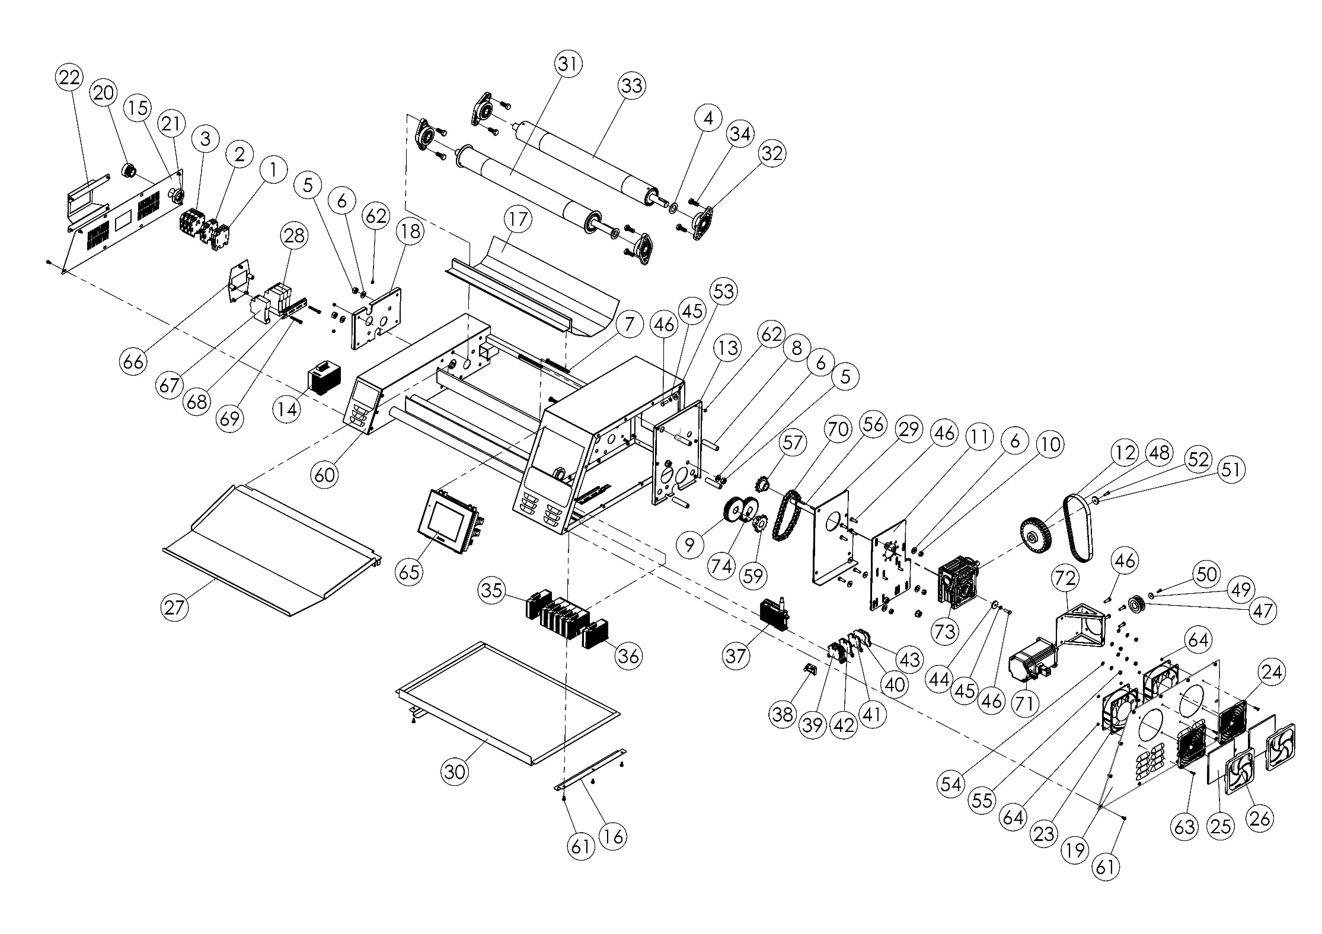

M00415 (FRONT) SPARE PARTS LIST
ITEM | SPARE PART NUMBER | DESCRIPTION OF THE SPARE PART | UNIT |  | ITEM | SPARE PART NUMBER | DESCRIPTION OF THE SPARE PART | UNIT
1 | 01386 | TERMINAL (GROUNDING) | 1 |  | 39 | 00295 | TERMINAL | 2
2 | 01387 | TERMINAL (BLUE) | 1 |  | 40 | 01384 | TERMINAL COVER | 4
3 | 01293 | TERMINAL | 3 |  | 41 | 00294 | TERMINAL (BLUE) | 3
4 | 01216 | WASHER | 2 |  | 42 | 01385 | TERMINAL (GREY) | 1
5 | 01257 | NUT | 8 |  | 43 | 00293 | TERMINAL (GROUNDING) | 1
6 | 00277 | WASHER | 12 |  | 44 | 00006 | WASHER | 2
7 | 01265 | BOLT | 4 |  | 45 | 00042 | WASHER | 8
8 | 01234 | PIPE | 4 |  | 46 | 00041 | BOLT | 16
9 | 01228 | GEAR | 2 |  | 47 | 01014M | TRIGER PULLEY | 1
10 | 01959 | NUT | 8 |  | 48 | 01343 | TRIGER BELT | 1
11 | 01156M | ENGINE REDUCER SHEET | 1 |  | 49 | 01212 | WASHER | 1
12 | 01215 | PULLEY | 1 |  | 50 | 02520 | BOLT | 1
13 | 01449 | SUPPORT SHEET | 1 |  | 51 | 00098 | WASHER | 1
14 | 01284 | POWER SOURCE | 1 |  | 52 | 00049 | BOLT | 1
15 | 101068 | LEFT COVER | 1 |  | 53 | 02579 | NUT | 6
16 | 01078 | WASTE PAN RAIL | 2 |  | 54 | 00317 | NUT | 4
17 | 01022 | SCRAPER SHEET | 1 |  | 55 | 01305 | NUT | 4
18 | 01450 | SUPPORT SHEET | 1 |  | 56 | 01445M | REDUCER CORE SHAFT | 1
19 | 101005 | RIGHT COVER | 1 |  | 57 | 01187 | SPROCKET | 1
20 | 01184 | RECORD | 1 |  | 58 | 01268 | SETSKUR | 4
21 | 01089 | RECORD NUT | 1 |  | 59 | 01217 | SPROCKET | 1
22 | 101004 | FUSE GUARD SHEET | 1 |  | 60 | 00214M | FRONT BODY | 1
23 | 00059 | FAN | 2 |  | 61 | 00046 | BOLT | 25
24 | 20001 | FILTER COVER | 2 |  | 62 | 00053 | NUT | 11
25 | 20003 | FILTER SPONGE | 2 |  | 63 | 01271 | BOLT | 8
26 | 20002 | FILTER COVER | 2 |  | 64 | 02634 | NUT | 8
27 | 01004M | OUT SHEET | 1 |  | 65 | 01492M | SCREEN | 1
28 | 101083 | FUSE | 3 |  | 66 | 01118M | FUSE SHEET | 1
29 | 01099M | TENSION SHEET | 1 |  | 67 | 01388 | FUSE | 1
30 | 01077 | FRONT WASTE PAN | 1 |  | 68 | 01028 | TERMINAL RAIL | 1
31 | 01253M | DRUM | 1 |  | 69 | 01391 | BOLT | 2
32 | 01434M | BELT | 4 |  | 70 | 01346 | CHAIN | 1
33 | 01254M | DRUM | 1 |  | 71 | 01013M | ENGINE | 1
34 | 01264 | BOLT | 8 |  | 72 | 01491 | ENGINE CONNECTION SHEET | 1
35 | 01440M | HEAT CARD | 6 |  | 73 | 01396 | REDUCER | 1
36 | 01436M | HEAT CARD | 1 |  | 74 | 01727 | SETSKUR | 2
37 | 01495M | PLC | 1
38 | 00292 | LIMITER | 1

M00414
BODY

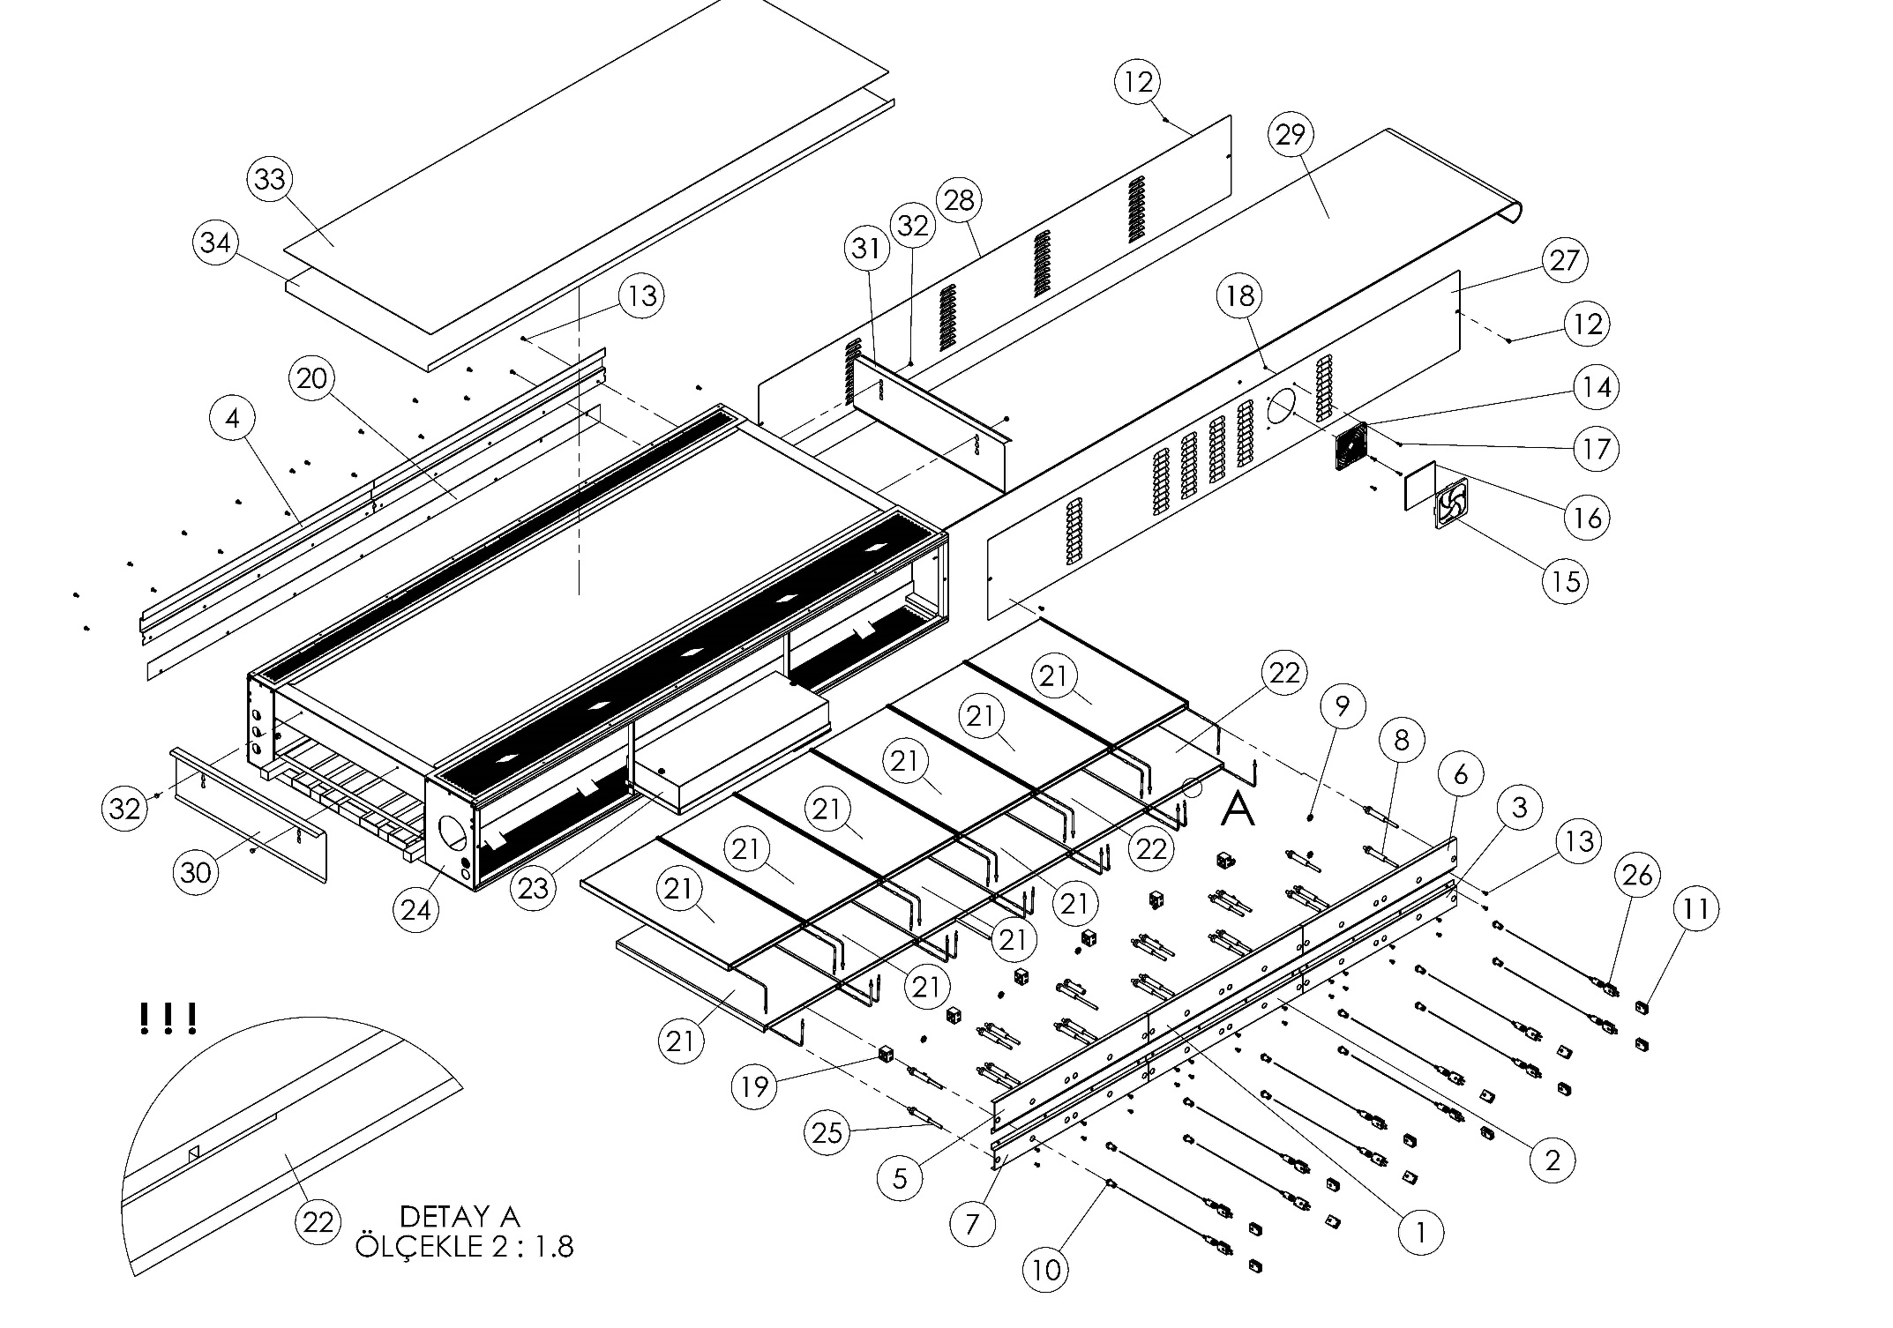

DETAIL A
SCALE 2: 1.8

M00414 (BODY) MATERIAL LIST
ITEM | SPARE PART NUMBER | DESCRIPTION OF THE SPARE PART | UNIT |  | ITEM | SPARE PART NUMBER | DESCRIPTION OF THE SPARE PART | UNIT
1 | 01142 | TOP MID REZISTANCE OUT SHEET | 1 |  | 18 | 02634 | NUT | 22
2 | 01143 | BOTTOM MID REZISTANCE OUT SHEET | 1 |  | 19 | 01311 | STONE TERMINAL | 6
3 | 01144 | BOTTOM RIGHT REZISTANCE OUT SHEET | 1 |  | 20 | 01262 | REZISTANCE SUPPORT SHEET | 1
4 | 01146 | TOP REZISTANCE SUPPORT SHEET | 2 |  | 21 | 01037M | REZISTANCE | 10
5 | 01147 | TOP LEFT REZISTANCE OUT SHEET | 1 |  | 22 | 01021M | REZISTANCE | 2
6 | 01148 | TOP RIGHT REZISTANCE OUT SHEET | 1 |  | 23 | M00330 | SSR BOX | 1
7 | 01145 | BOTTOM LEFT REZISTANCE OUT SHEET | 1 |  | 24 | 00438M | BODY | 1
8 | 01314 | REZISTANCE CABLE STONE | 24 |  | 25 | 01317 | REZISTANCE OUT TUBE | 24
9 | 01310 | NUT | 12 |  | 26 | 01041M | THERMOCOUPLE | 12
10 | 01309 | THERMOCOUPLE NUT | 12 |  | 27 | 101073 | RIGHT COVER | 1
11 | 01282 | THERMCOUPLE PLUG | 12 |  | 28 | 101074 | LEFT COVER | 1
12 | 00046 | BOLT | 4 |  | 29 | 01406 | BELT | 1
13 | 00278 | BOLT | 42 |  | 30 | 01436 | HEAT CHAMBER COVER | 1
14 | 20001 | FILTER COVER | 1 |  | 31 | 01435 | BODY COVER SHEET | 1
15 | 20002 | FILTER COVER | 1 |  | 32 | 01441 | PIN | 4
16 | 20003 | FILTER SPONGE | 1 |  | 33 | 01149 | TOP COVER | 1
17 | 01319 | BOLT | 4 |  | 34 | 01137 | TOP UNSILATION SHEET | 1

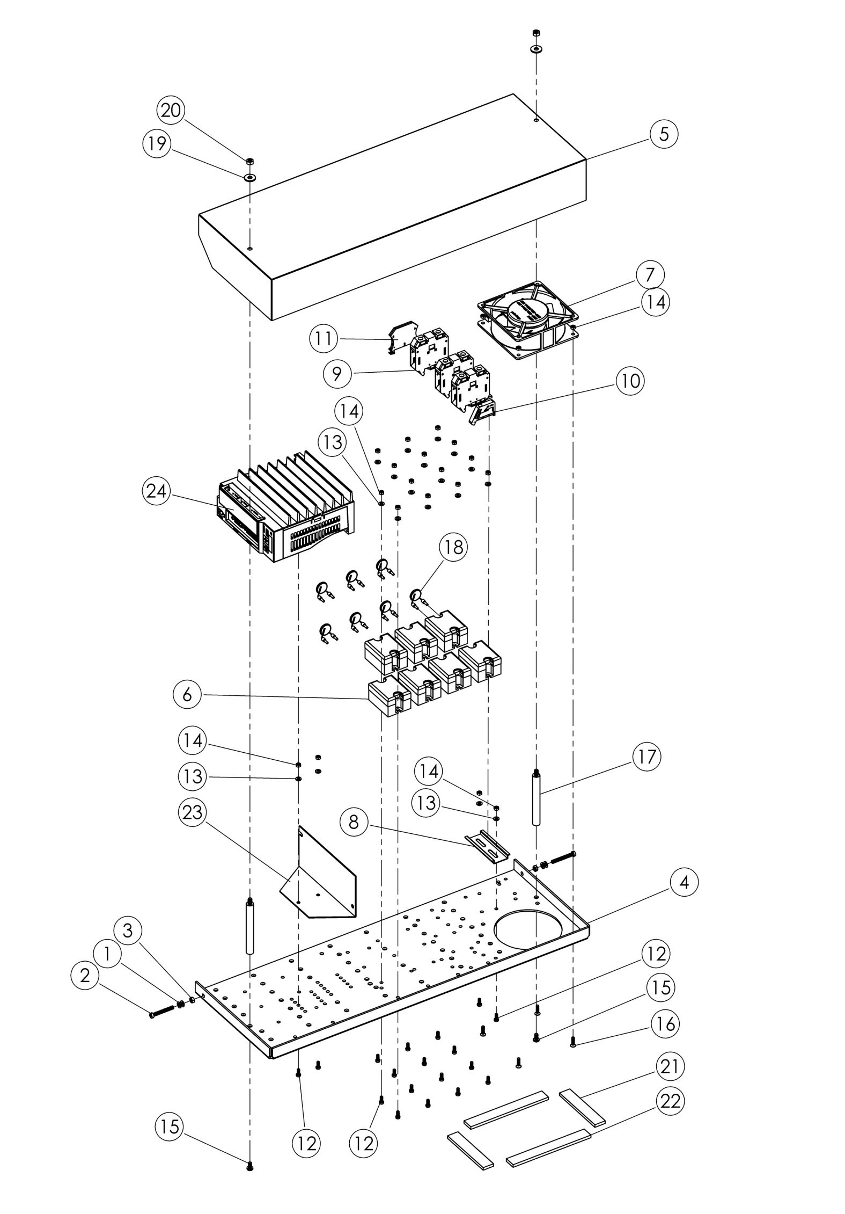
M00330
SSR BOX

M00330 (SSR BOX) SPARE PART LIST
ITEM # | SPARE PART NUMBER | DESCRIPTION OF THE SPARE PART | UNIT
1 | 02582 | WASHER | 4
2 | 01303 | BOLT | 2
3 | 00052 | NUT | 2
4 | 01432 | SSR SHEET | 1
5 | 01139 | SSR COVER | 1
6 | 01286 | SSR RELAY | 7
7 | 01290 | FAN | 1
8 | 00075 | TERMINAL RAIL | 1
9 | 01293 | TERMINAL | 3
10 | 00292 | LIMITER | 1
11 | 00293 | TERMINAL (GROUNDING) | 1
12 | 01295 | BOLT | 18
13 | 01296 | WASHER | 18
14 | 02634 | NUT | 22
15 | 00278 | BOLT | 2
16 | 01271 | BOLT | 4
17 | 01429 | STUD | 2
18 | 01292 | VARISTOR | 7
19 | 01299 | WASHER | 2
20 | 01305 | NUT | 2
21 | 01306 | SPONGE | 2
22 | 01307 | SPONGE | 2
23 | 01428 | SPEED CONTROL SHEET | 1
24 | 01342 | SPEED CONTROL UNIT | 1

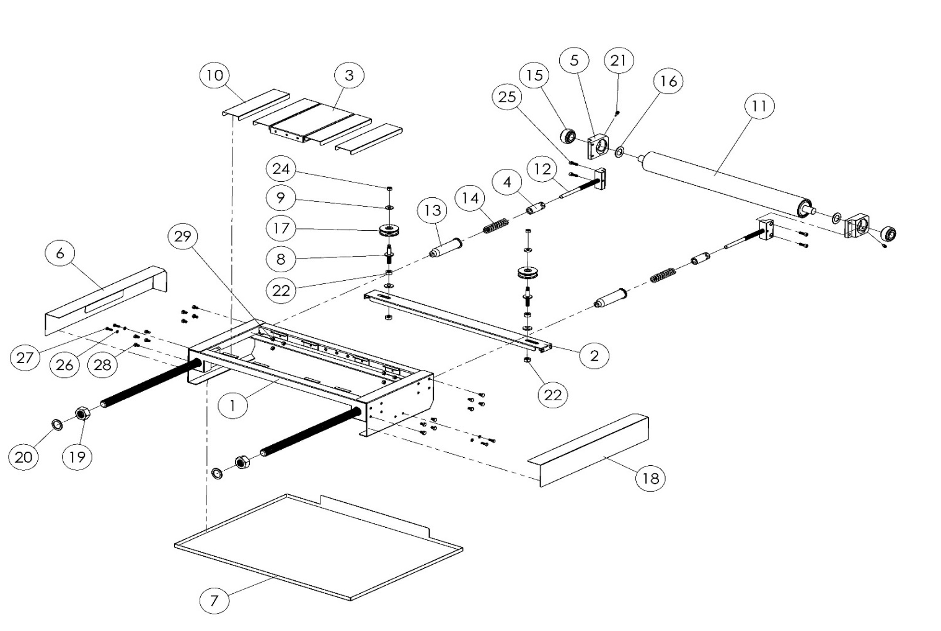
M00413 BACK

M00413 (BACK) SPARE PARTS LIST
ITEM # | SPARE PART NUMBER | DESCRIPTION OF THE SPARE PART | UNIT
1 | 00437M | REAR CHASIS | 1
2 | 00210M | PULLEY CHASIS | 1
3 | 101021 | REAR BAND SUPPORT COVER | 1
4 | 01185 | NUT | 2
5 | 01242 | DRUM BEARING | 2
6 | 101022 | REAR BEARING PROTECTING SHEET | 1
7 | 101023 | REAR RESIDUAL TRAY | 1
8 | 01191 | STUD | 2
9 | 00044 | WASHER | 2
10 | 101020 | REAR BAND SUPPORT COVER | 4
11 | 01255M | DRUM | 1
12 | 01297M | TENSIONER STUD | 2
13 | 01233 | TENSIONER HOUSING | 2
14 | 01222 | TENSION SPRING | 2
15 | 01052M | BEARING | 2
16 | 01216 | WASHER | 2
17 | 01057M | PULLEY | 2
18 | 101029 | BACK BEARING GUARD SHEET | 1
19 | 01260 | NUT | 2
20 | 01192 | WASHER | 2
21 | 01246 | BEARING SETSKUR | 2
22 | 01257 | NUT | 4
23 | 01258 | PUL | 2
24 | 01959 | NUT | 2
25 | 01256 | BOLT | 4
26 | 04077 | WASHER | 4
27 | 01259 | BOLT | 4
28 | 03412 | BOLT | 16
29 | 03086 | NUT | 8

SECTION 8: ELECTRICAL DIAGRAM
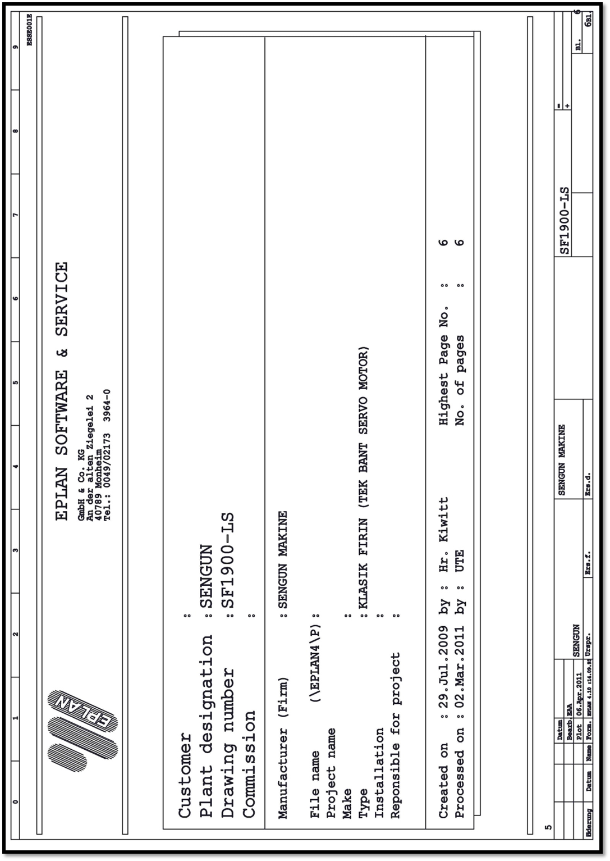
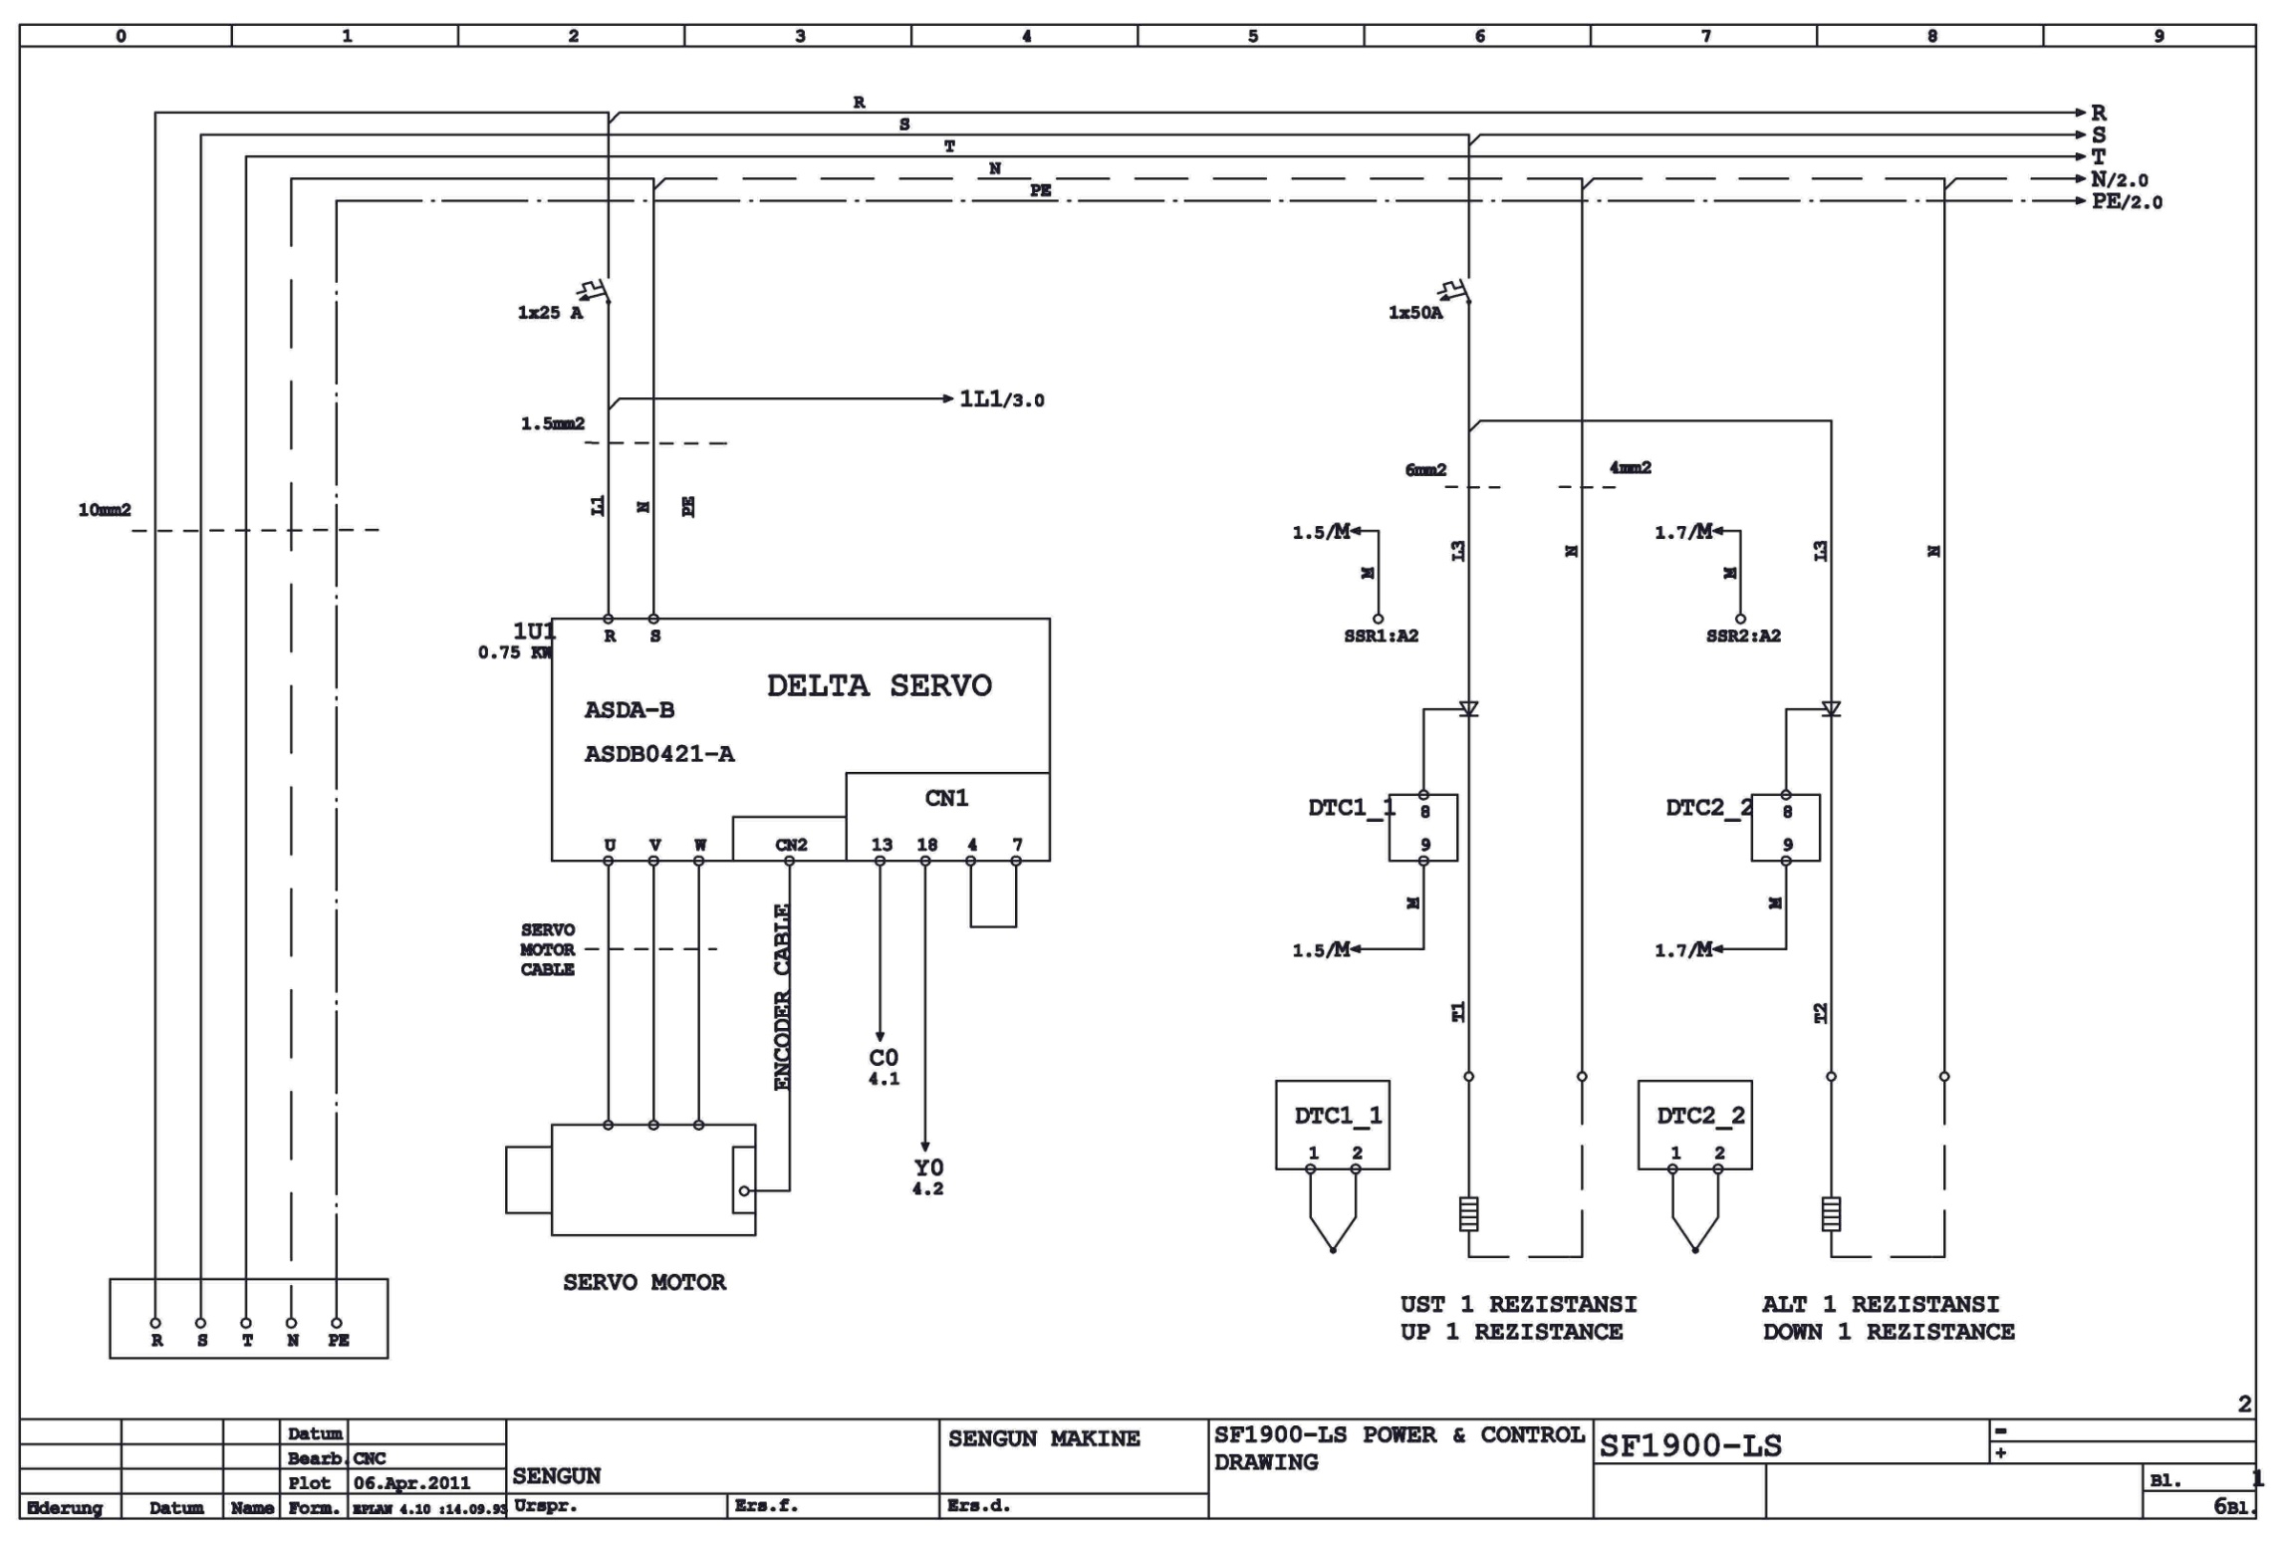

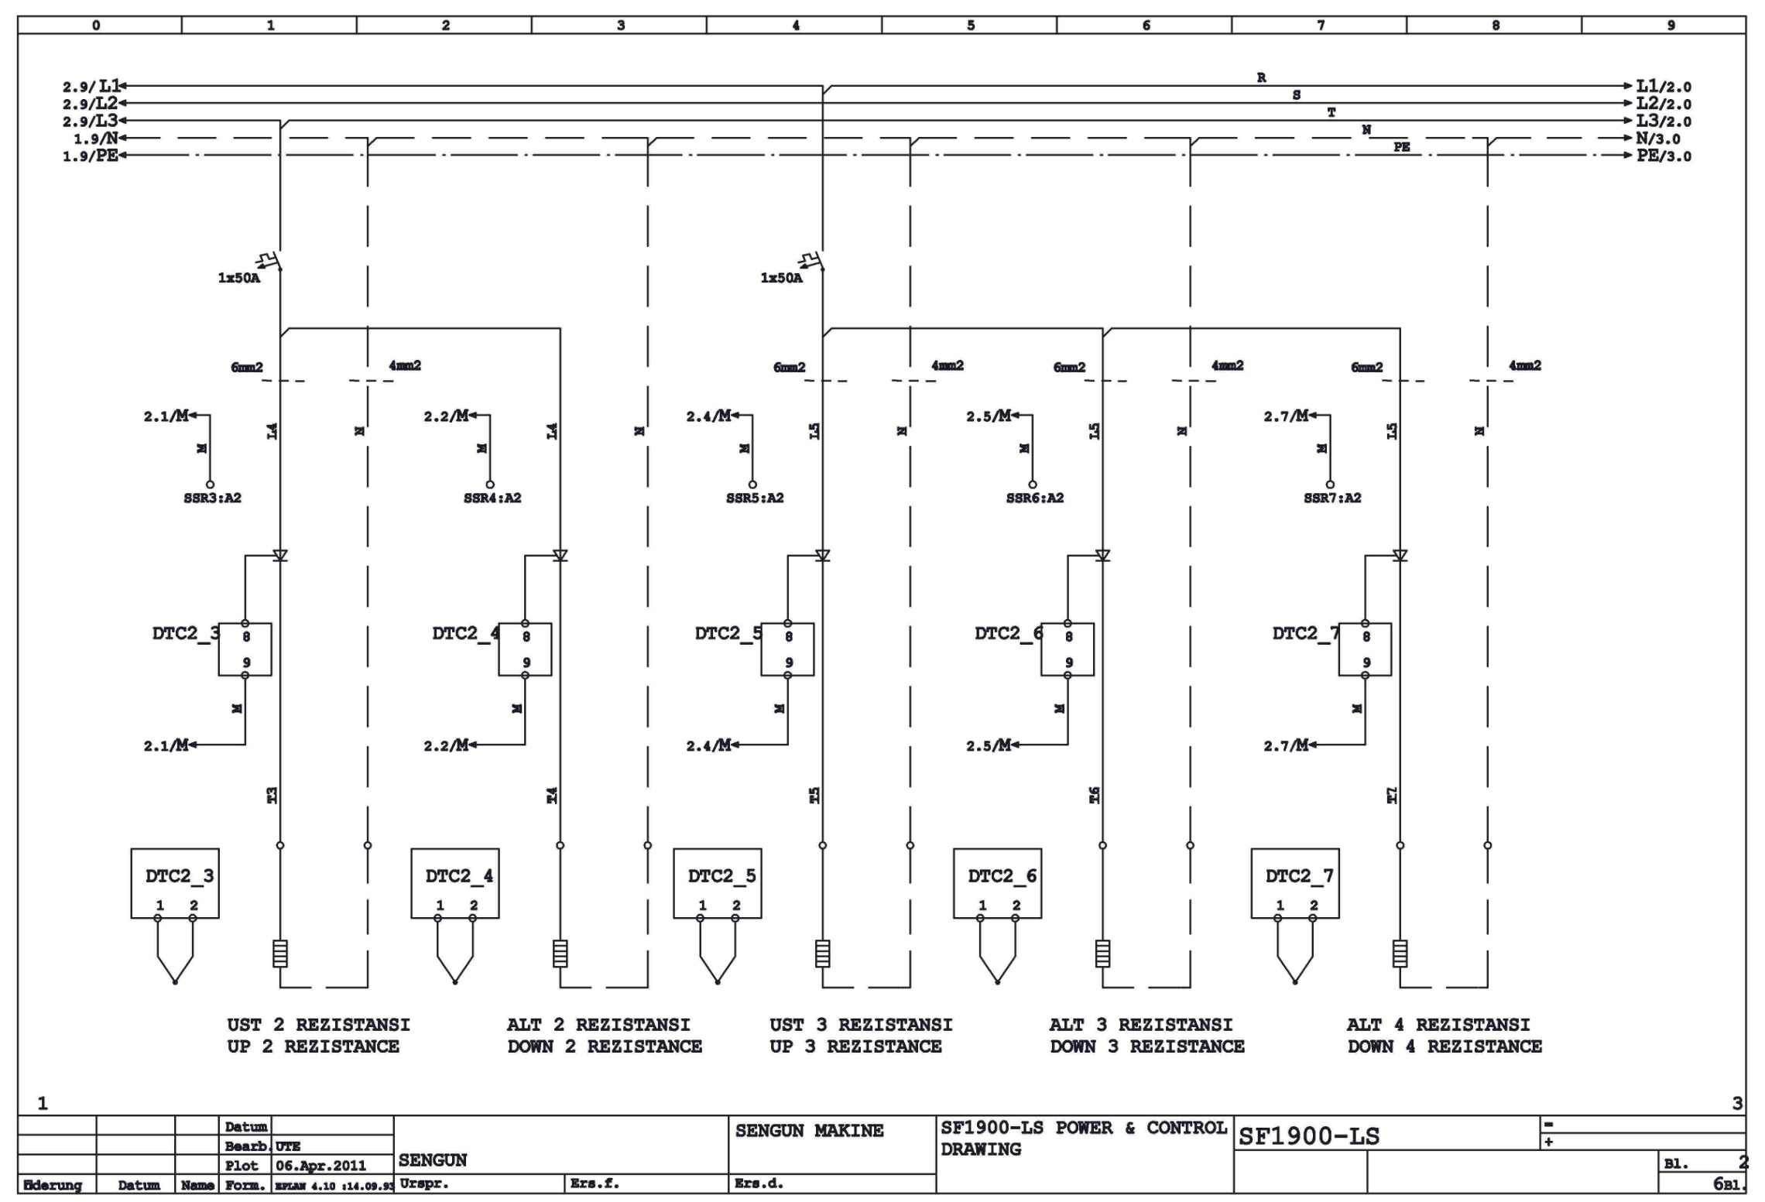

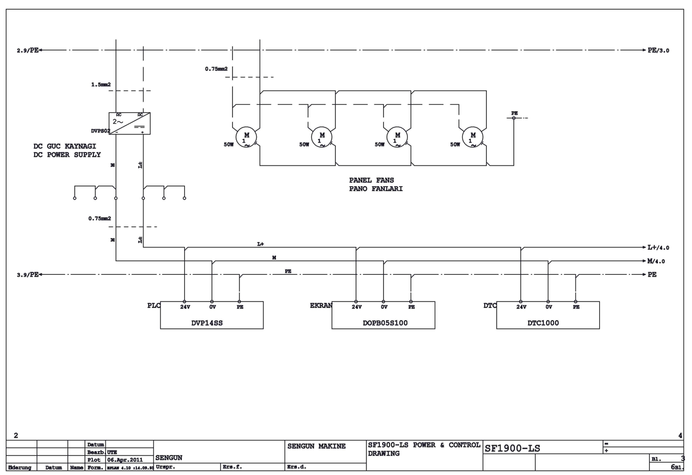

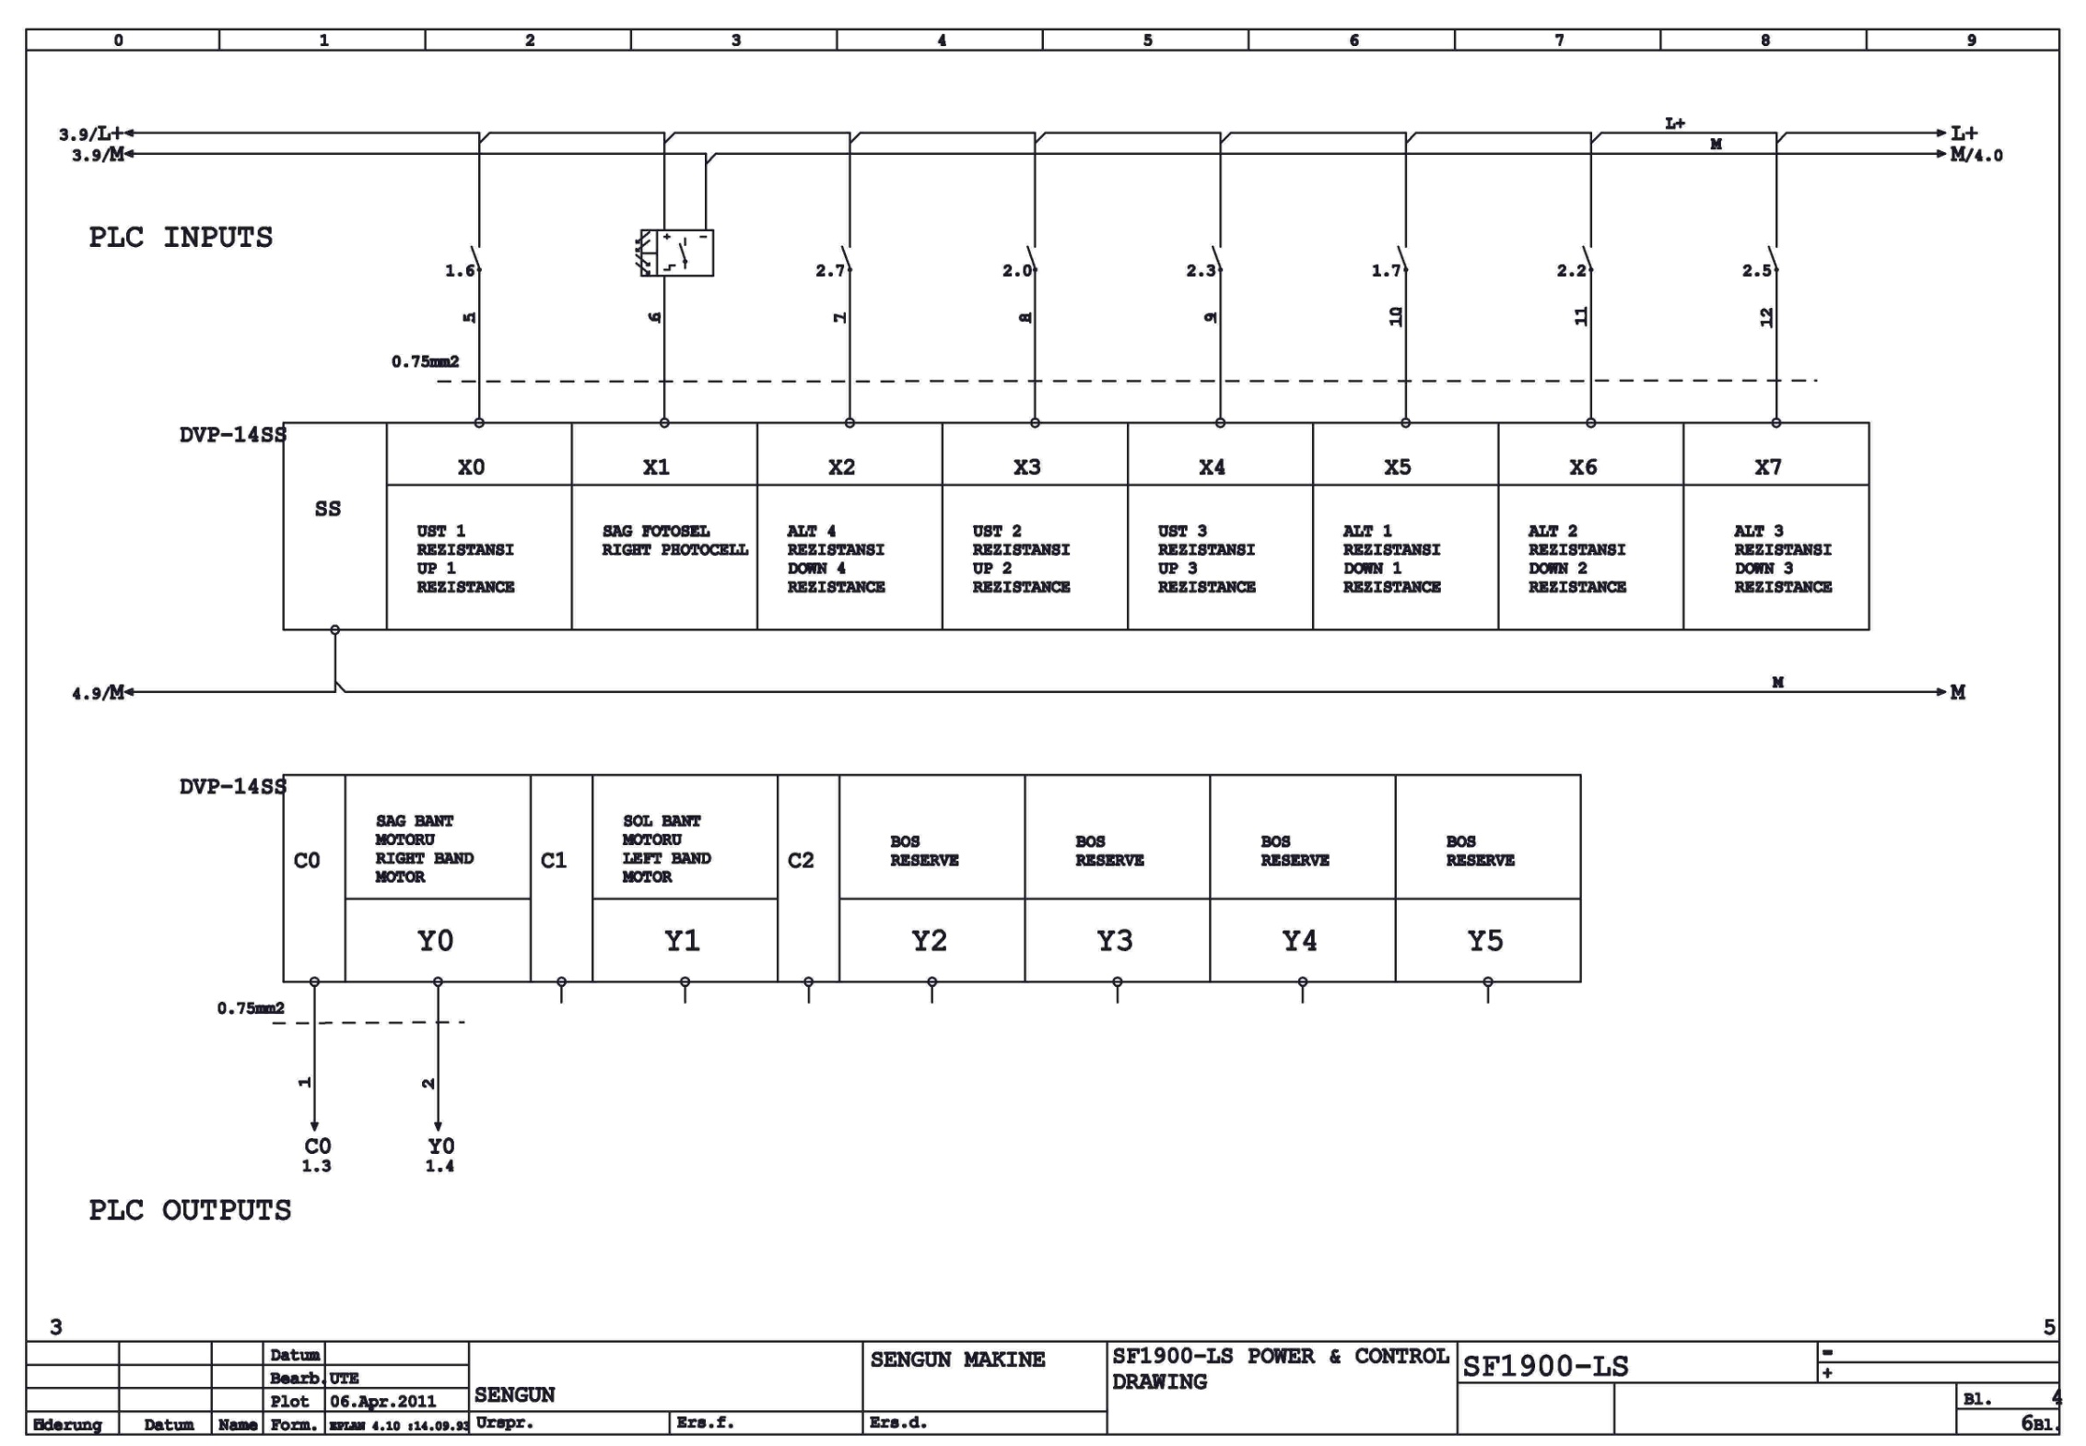

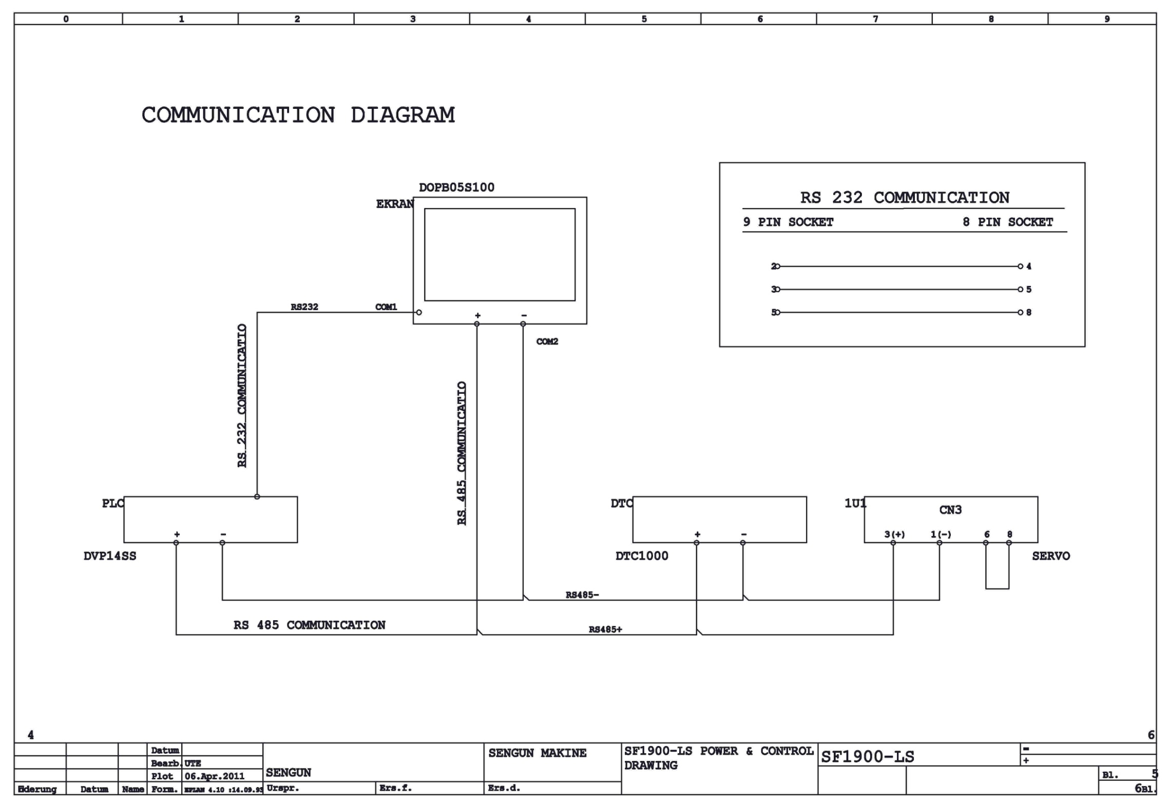

SECTION 9: TROUBLESHOOTING
9.1 Warning of Temperature Limit exceeded
This warning shows that the temperature limit (550 °C for TOP– 450 °C for BOTTOM) has been exceeded in any zone. The oven is stopped and the belt turns until the hot zone gets cold. After that, the oven is reset by turning off and on the switch (fuse).
The indication of temperature limit exceeded

Reset the oven by using on-off function

Check the heat on cooking page

Heat is high

0 Volt

Measure the input voltage of relay DC terminals no 3-4

Check the relay outlet voltage fron 1 and 1

Change relay between 100-200 V

12 Volt + / -

Change 0 V relay

Check the cables coming to relay

200-230 V relay durable

0 DC card or cable is improper

Find the earthed shor circuit of the heaters. Do this when the oven is hot and in stop position.

Infinite resistance

Resistance in RX1 shows grounding.

Heaters have floating circuit

Remove the covers and check the chassis contact of the heaters.

There may be heat transfer from other zones.

Disconnect and reconnect it if there is contact but no damage.

Change the heater if there is no contact or it is damaged.

Do this with the help of a skilled electrician. If the problem continues and the products burn, call the service.

9.2 Indication of "Low Battery" is displayed
Turn on and off the switch.

If the display turns into normal, the error message may be due to any loose contact or low voltage.

No change.

The screen continues to work well for a month even though this error message is displayed.

The screen battery is required to be changed within such period of a month if the screen has energy. The battery changed when the screen has no energy causes failure of the programs written.

Note: Battery is supplied through electronics store-service-manufacturing company.

9.3 Conveyor stopped totally or working interruptedly
Check the cooking time adjustment.

Inspect the cyclinders turning the conveyor belt if its speed is set to 10 min or less.
Conveyor will stop sometimes if its speed is set to 10 min or more. It is not a problem.

Conveyor cyclinders are not turning.
Conveyor cyclinders are turning.

The conveyor belt may be loosen. Conveyor belt is required to be adjusted Call the service.
Check the conveyor motor and transfer chain, it they are working properly, check the motor speed and control device.

If there is a problem in speed control device, check if any object stuck into the belt, if so, take off it.

If no problem is seen in motor speed control device, call the service.

After the conveyor is cleared of any object stuck, reset the oven and push the run button of speed control and reoperate it.

If it doesn't work still, call the service.

9.4.Products not cooked
Products not cooked

Check the cooking time and settings. The CONVEYOR may be turning too fast.

The temperature of one or more heating zones may be low.

Stop the oven. Turn on and off the switch near the electric box for 2-3 times. Start it.

If the same error message is still seen on the display, call the service.
It shows the warning of ready in the display. The error recovered.

9.5 Contact with Technical Services:
If the oven fails to operate, check the circuit breaker to be sure it is turned on. In addition, be sure that the circuit breaker is good before you call the Authorized Service Agency. The name and phone number of the Authorized Service Agency should be located on the oven or contact the factory for the name of the nearest Authorized Service Agency.

SECTION 10: LABELS



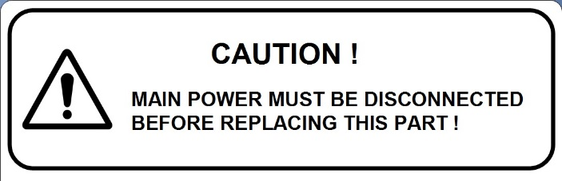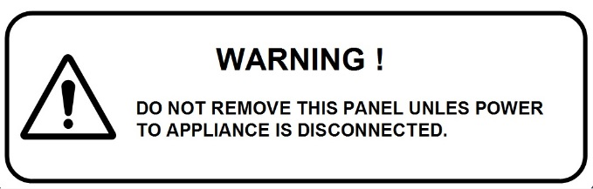
Warning Label Warning Label
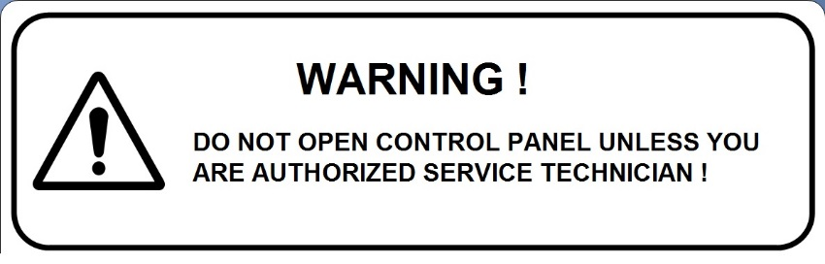
Warning Label


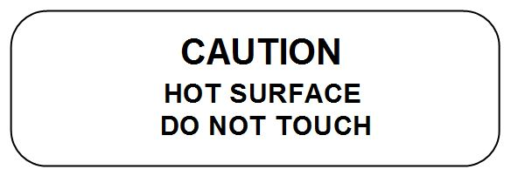

Warning Label CE Compliance to European Norms

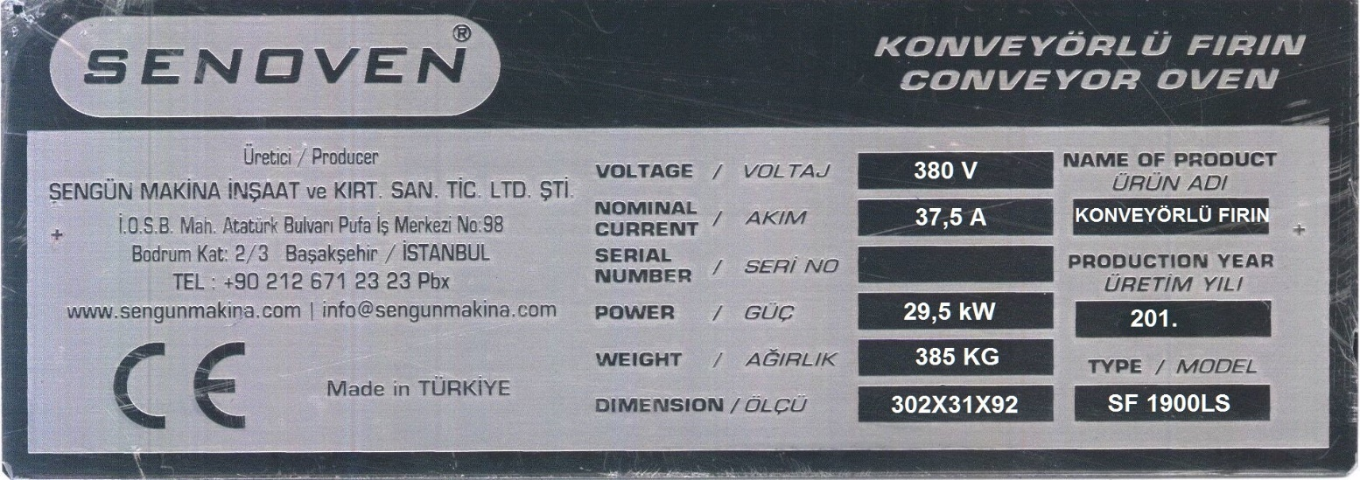
Technical Label (Product Card)

NOTE:



ŞENGÜN MAKİNA İNŞAAT VE KIRTASİYE SAN. TİC. LTD. ŞTİ.
İkitelli Organize Sanayi Bölgesi, Atatürk Bulvarı, Pufa İş Merkezi No: 98 Bodrum Kat: 2-3
Başakşehir/ İstanbul/ Türkiye

Phone: +90 212 671 23 23 (Pbx)
Phone 2: +90 212 671 84 84
Fax: +90 212 671 88 28
GSM: +90 533 957 14 53

e-Mail : info@sengunmakina.com
web : www.sengunmakina.com

